

4ID3 - IoT Devices and Networks

Lab 4 (2 week lab)

Communicating Sensor Data over a LoRaWAN Network

Adam Sokacz, Vincent Lombardi, Ishwar Singh, and Salman Bawa

Sponsored by [*Future Skills Center, Canada*](https://fsc-ccf.ca/) and[*McMaster W Booth SEPT*](https://www.eng.mcmaster.ca/sept)

Group Number:

Name, Student Number:

Name, Student Number:

Name, Student Number:

Submission Date:

# Objective

In this lab, sensor data will be collected on the MKRWAN development board and transmitted over LoRaWAN to The Things Stack using a LoRaWAN Indoor Gateway as an intermediary. The Application Layer will be integrated with MQTT. Each uplink will be automatically committed to a local MySQL server for data collection and analysis.

Contents

Objective 2

Feedback 4

Additional Resources 4

Pre-Lab Questions 5

Post-Lab Questions 5

Exercise A Results: 7

Exercise B Results: 7

Exercise C Results: 7

Setting up the Workspace 8

Setting Up a LoRaWAN Gateway 9

Logging into ThingStack 9

Connecting the Gateway to The Things Stack 12

Gateway Configuration 12

Registering the Gateway 14

Creating an Application 16

Creating a LoRaWAN Field Device 18

Finding your Device Configuration 18

Registering your Device in your Application 20

Field Device 24

MQTT Integration 33

Data Collection and Analysis 38

Installing MySQL & MySQL Connector 38

Exercise A 45

Data Collection 45

Python Virtual Environment 45

Creating the Database 51

Converting Database to Excel 53

Connecting MQTT to your Local MySQL Database 53

Parsing the Database (Simple) 54

Parsing the Database (Advanced) 55

Exercise B 58

Installing Visual Studio 59

Creating a WinForms Desktop Application 61

Setup 61

Adding Elements 65

Installing NuGet Packages 70

Creating a Database Model 72

Creating a WinForms User Interface 79

Syncing with GitHub 91

# Feedback

Q1 - What would you rate the difficulty of this lab?

*(1 = easy, 5 = difficult)*

|  |  |  |  |  |
| --- | --- | --- | --- | --- |
| **1** | **2** | **3** | **4** | **5** |

Comments about the difficulty of the lab:

Q2 - Did you have enough time to complete the lab within the designated lab time?

|  |  |
| --- | --- |
| **YES** | **NO** |

Q3 - How easy were the lab instructions to understand?

*(1 = easy, 5 = unclear)*

|  |  |  |  |  |
| --- | --- | --- | --- | --- |
| **1** | **2** | **3** | **4** | **5** |

List any unclear steps:

Q4 - Could you see yourself using the skills learned in this lab to tackle future engineering challenges?

*(1 = no, 5 = yes)*

|  |  |  |  |  |
| --- | --- | --- | --- | --- |
| **1** | **2** | **3** | **4** | **5** |

# Additional Resources

**Lab GitHub Repo** ( <https://github.com/sokacza/4ID3> )

MySQL Basics ( <https://youtu.be/Cz3WcZLRaWc> )

NodeRED Fundamentals Tutorial ( <https://youtu.be/3AR432bguOY> )

Arduino MKRWAN (<https://youtu.be/UmcA2moPWAY> )

# Pre-Lab Questions

Q1 - Name 6 advantages of LoRaWAN over other access technologies.

(Suggested: Short paragraph)

Q2 - LoRaWAN specifies 3 types of devices: Class A, Class B, and Class C. Compare and contrast each in a table.

(Suggested: Table)

Q3 - LoRaWAN end devices support 2 activation methods. Name these methods. Compare and contrast them in a table.

(Suggested: Table)

Q4 - What is The Things Network and how does it differ from LoRaWAN itself? What layer of the OSI model does each lie?

(Suggested: Short paragraph)

# Post-Lab Questions

Q1 - Draw a diagram to identify each component of the IoT network produced in this lab and describe the information being exchanged between the components.

(Suggested: Sketch)

Q2 - What is Cisco SD-WAN? Compare and contrast it with The Things Network in a table.

(Suggested: Table)

Q3 - You have a database named `KGB_TOP_SECRET` and a table in that database named `LOGIN_CREDENTIALS`. What is the SQL query to **use** that database?

(Suggested: 1 Sentence)

Q4 - You have a database named `KGB_TOP_SECRET` and a table in that database named ` LOGIN_CREDENTIALS `. What is the SQL query to **select**/print all columns of that table to the terminal?

(Suggested: 1 Sentence)

Q5 - You have a database named `KGB_TOP_SECRET` and a table in that database named ` LOGIN_CREDENTIALS `. There are two columns in this table: `USERNAME`, `PASSWORD`. What is the SQL query to **insert** a new set of **values**, a row into the table that includes a username and password string fields? (Keep in mind ` symbol vs ‘ symbol)

username = ‘#TheRealJamesBond’

password = ‘007’

(Suggested: 1 Sentence)

Q8 – We can use SQL Queries to **connect**, **insert** data into, and **read** from a MySQL database. You have the following MySQL database:

|  |  |  |  |
| --- | --- | --- | --- |
| IOT_DEVICES | | | |
| ID | DEVICE_NAME | SENSOR_NAME | SENSOR_VALUE |
| 1 | DeviceC | Temperature | 24.6 |
| 2 | DeviceF | Temperature | 28.9 |
| 3 | DeviceU | Temperature | 102.3 |

Notice that the temperature in row #3 is much higher than other devices. Write a **SQL query** that will **select** all the database rows **where** a temperature is **greater than 30.0** degrees.

Expected output:

|  |  |  |  |
| --- | --- | --- | --- |
| IOT_DEVICES | | | |
| ID | DEVICE_NAME | SENSOR_NAME | SENSOR_VALUE |
| 3 | DeviceU | Temperature | 102.3 |

(Suggested: 1 – 2 sentences)

Q6 - We saw these terms a lot in this lab: **EUI**, **API Key**. What do each of these terms mean in the context of LoRa and LoRaWAN communication?

(Suggested: Short paragraph)

Q7 - In this lab, we used the **915 MHz** LoRaWAN frequency, which is a legal frequency band in North America. Using online resources, calculate the theoretically suggested antenna length when transmitting at this frequency. Show your calculations below.

(Suggested: Short paragraph)

Q6 – When looking at a LoRaWAN **data frame**, you notice that you receive the **payload data** as a **hex character string**.

*[6c, 6f, 72, 61, 77, 61, 6e, 20, 72, 6f, 63, 6b, 73]*

a) Convert each hex character to decimal form using the following online calculator:

<https://www.rapidtables.com/convert/number/hex-to-decimal.html>

*[ … ]*

b) Convert each decimal character to its ASCII representation using the following online calculator:

<https://onlineasciitools.com/convert-decimal-to-ascii>

*[ … ]*

Q8 - Write a brief LinkedIn post about key learning takeaways from this lab.

(Suggested: Short paragraph)

# Exercise A Results:

# Exercise B Results:

# Exercise C Results:

# Setting up the Workspace

Using Git Bash or Windows Terminal, navigate to your lab repository and issue the following commands:

*git pull origin main*

<Create your Lab04 folder>

<Create your Lab4 README.md file>

*git add .*

*git commit -m “Starting Lab04”*

*git push origin main*

*git pull origin main*

# Setting Up a LoRaWAN Gateway

## Logging into ThingStack

Navigate to The Things Network:

<https://www.thethingsnetwork.org/>

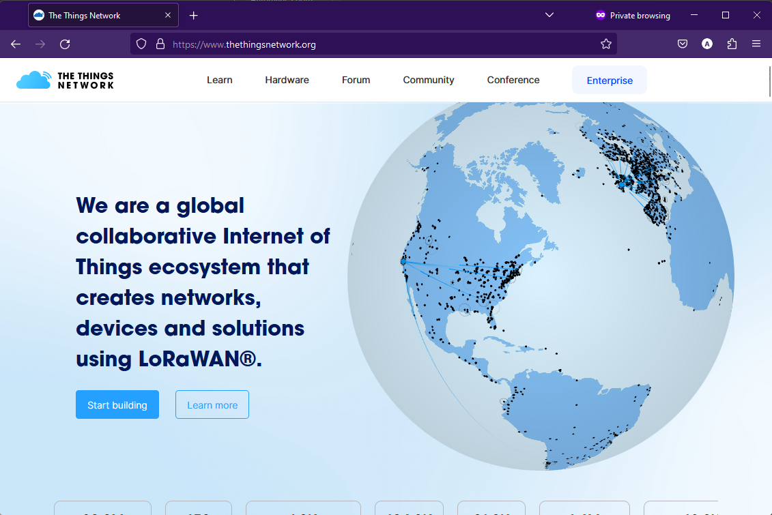

Press **Login**.

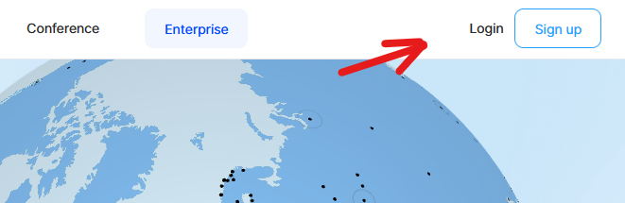

Use the credentials provided by the lab instructor.

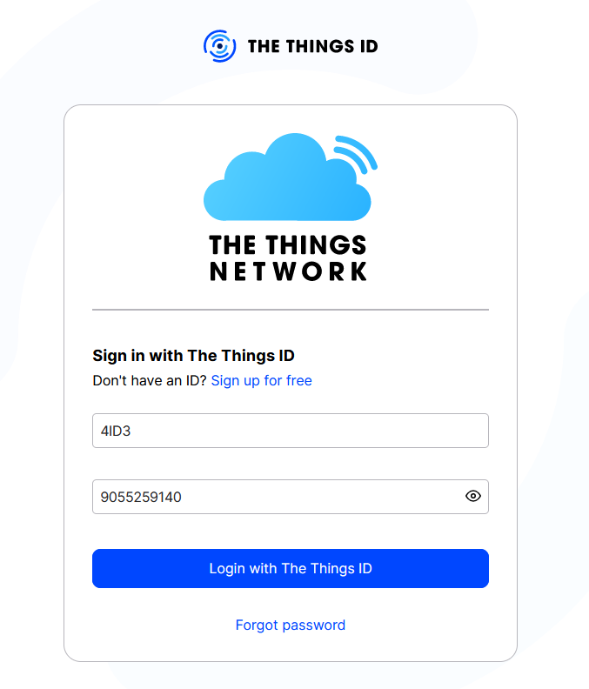

Login Credentials:

*Username:* 4ID3

*Password:* 9055259140

*\*McMaster general phone number*

Once logged in, navigate to the **Console**.

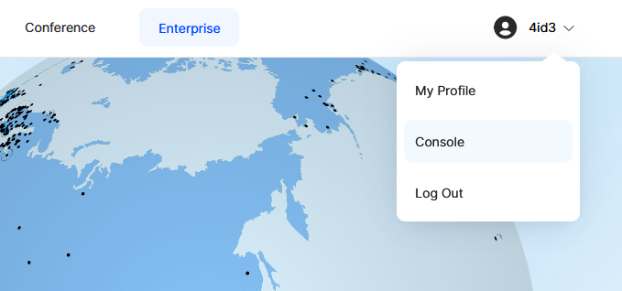

Select the **North American Cluster**.

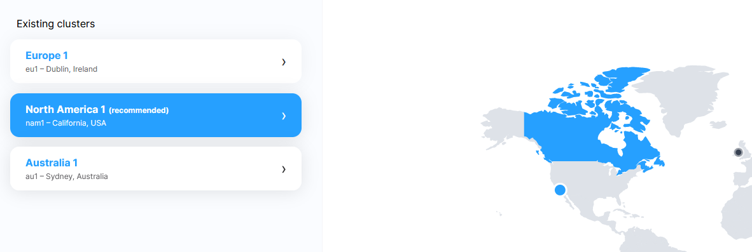

You will be redirected to the welcome page.

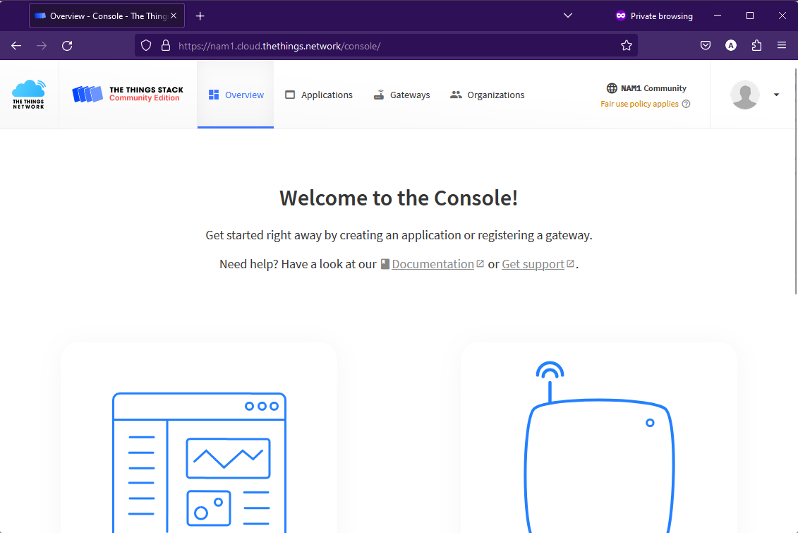

Notice the **region** in the top right corner.

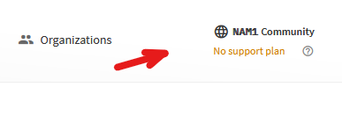

## Connecting the Gateway to The Things Stack

### Gateway Configuration

Keep the RESET button (small button at the back of the gateway next to the USB-C port) pressed for 5 seconds until the LED blinks rapidly from GREEN to RED and vice versa for a couple of times.

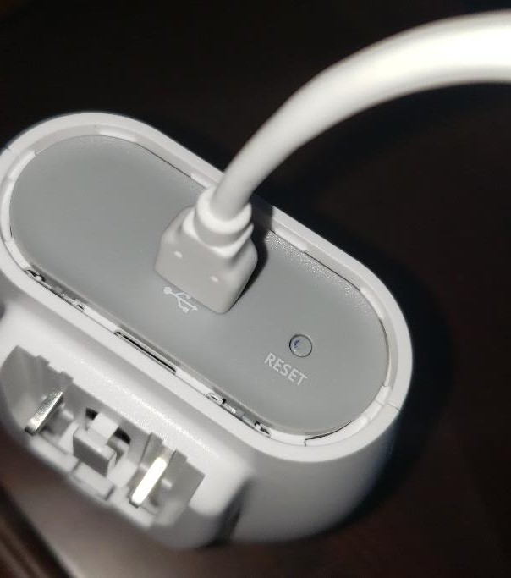

Hold the **setup button** (at the top of the gateway, next to the LED) for **10 seconds** until the LED **rapidly blinks RED**.

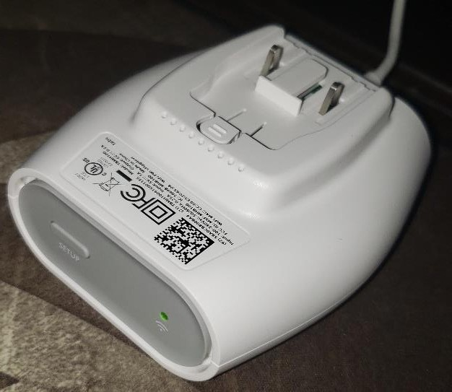

The gateway now exposes a **Wi-Fi access point** whose **SSID** is **MINIHUB-xxxxxx**, where xxxxxx is the last **6 digits of the gateway EUI**. The password for this network is on the back of the device.

Connect to the network on your phone on computer. Note: If you are connecting to the device directly on your computer you will lose access to the Internet since you are communicating directly with the device.

Once connected, go to the following **URL** in your browser: [http://192.168.4.1](http://192.168.4.1/)

A page like the following should load: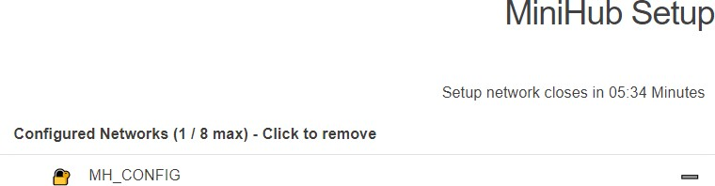

**IMPORTANT:** Take note of the **Gateway EUI** at the bottom of the page. This is necessary for adding the gateway to The Things Stack in the next steps. It is recommended to copy this table and save it to a notepad file on your desktop.

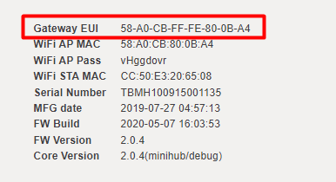

Find your Wi-Fi network in the list of scanned networks and enter your Wi-Fi password then press **Save & Reboot.**

You should see a prompt like this: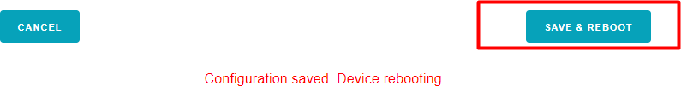

If your configuration is correct,

The gateway will blink **GREEN** for a few seconds until it connects to the selected WiFi network.

Then, it will blink from **GREEN** **to RED** and vice versa for a few seconds while it connects to the server and fetches the necessary configuration.

Please allow **5-10 minutes** for the gateway to pick up the **new configuration**.

## Registering the Gateway

Now that the Gateway is connected to our internet, we can register it in the console.

Go to **Gateways** in the top menu, and click **+ Register Gateway** to reach the gateway registration page.

Enter the **Gateway EUI** you copied earlier.

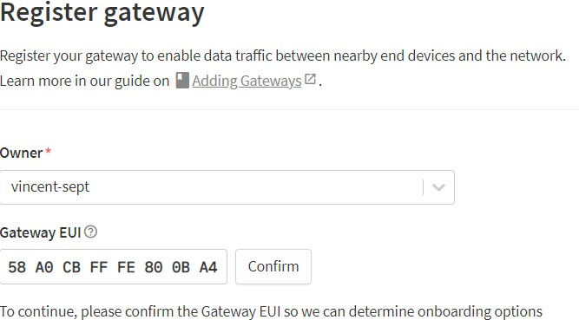

Use the **Wi-Fi password** of the device that was previously used to connect to its network as the  **Claim Authentication Code**. Then give the gateway a unique ID/name and set the Frequency Plan to United States **902-928 MHz, FSB 2.**

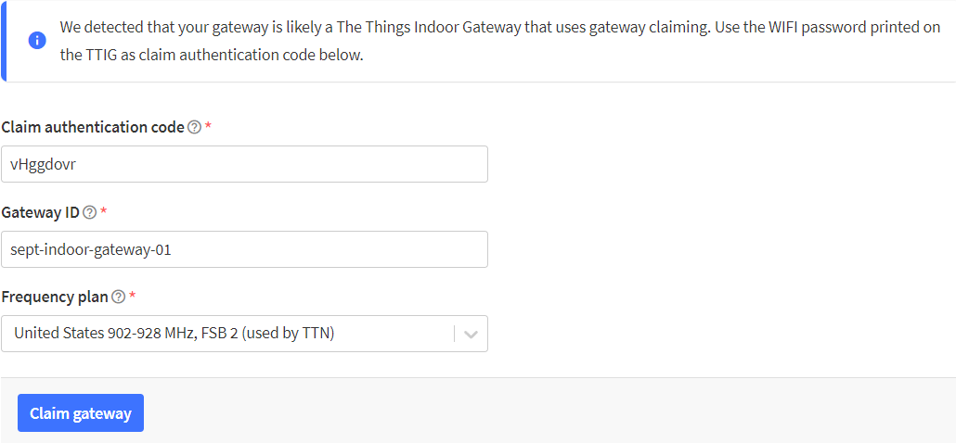

If your inputs are correct, a new gateway will be created, and you will be redirected to the gateway overview page of your newly created gateway.

If this is the first time your gateway is being powered on/connected to WiFi, it might pick up a **new firmware** depending on when it was last updated. This is indicated by **alternating GREEN/RED blinks** of the LED. Please **leave the gateway powered** on when this happens.

After a **few minutes**, the light on the Indoor Gateway should go **solid green**, and you should see the flow of packets in the console.

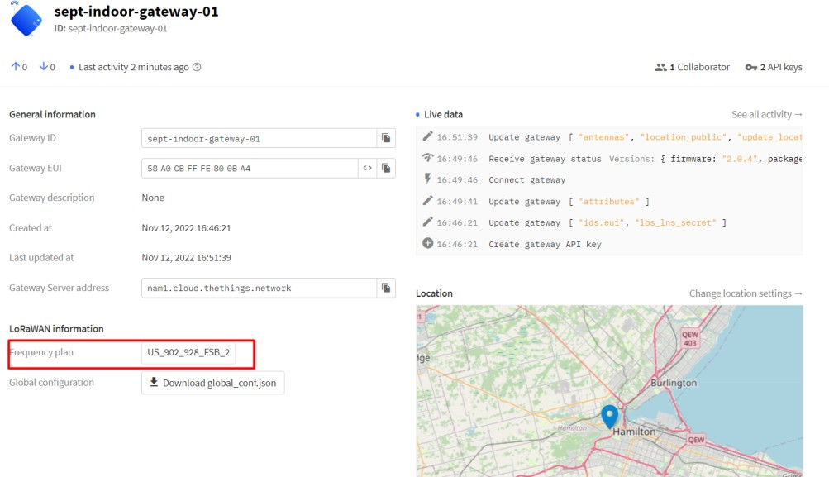

# Creating an Application

Go to **Applications** in the top menu, and click **+ Add Application** to reach the application registration page. Fill the application ID. The other fields are optional. In this example, we are making an application called **4ID3_GroupA_2023.**

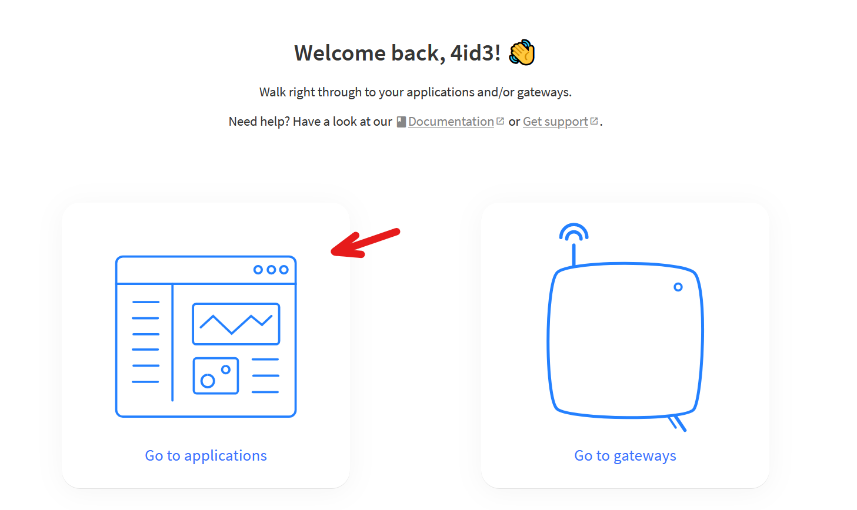

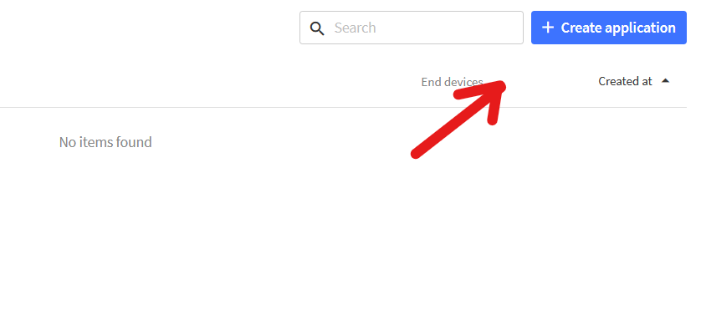

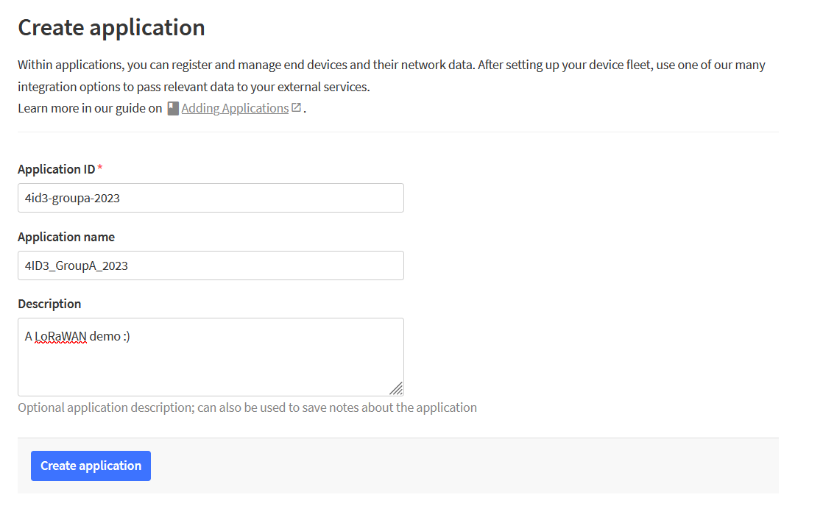

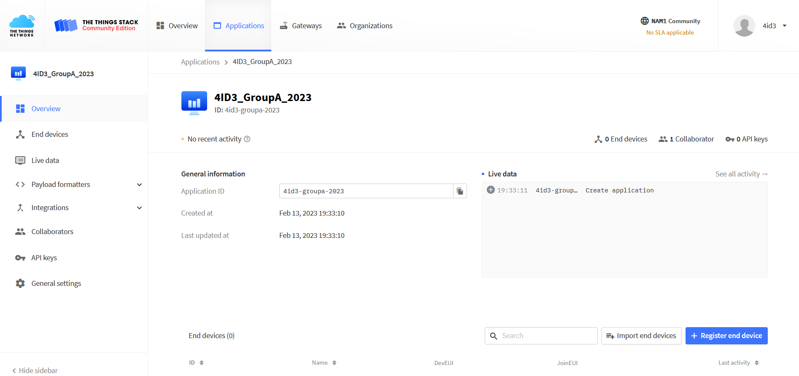

# Creating a LoRaWAN Field Device

## Finding your Device Configuration

There are a few libraries we need for this project:

* TheThingsNetwork
  + <https://github.com/TheThingsNetwork/arduino-device-lib>
  + Download and Install as ZIP
* Adafruit Unified Sensor by Adafruit Inc.
  + Install from Arduino library manager
* DHT Sensor Library by Adafruit Inc.
  + Install from Arduino library manager

Create a new Arduino project called **Configuration**.

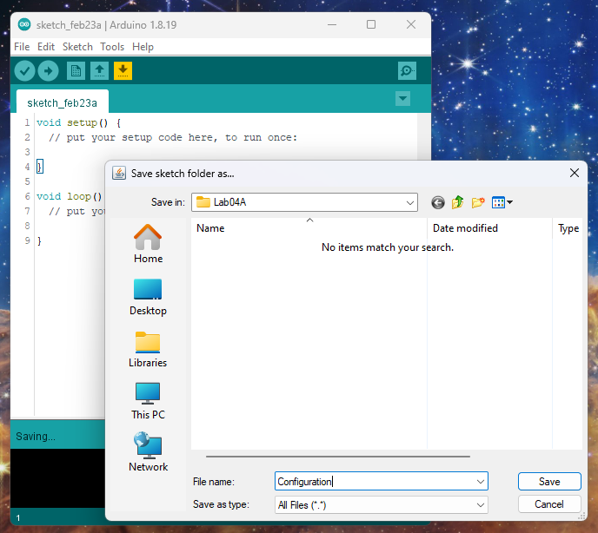

Set up your sketch as such:

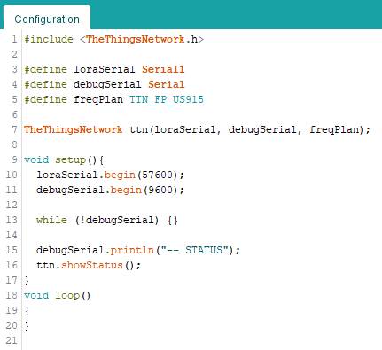

Upload it to your board, open the **serial monitor** and note the Device **EUI**.

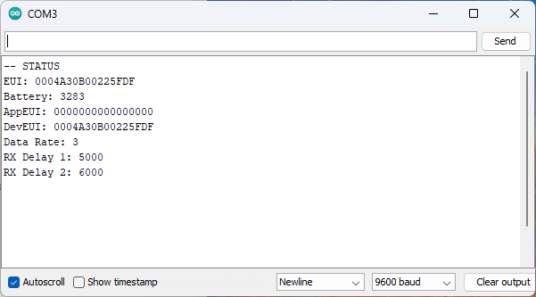

## Registering your Device in your Application

Navigate to your application dashboard and click **Register End Device**.

|  |
| --- |
|  |

Use the following configuration:

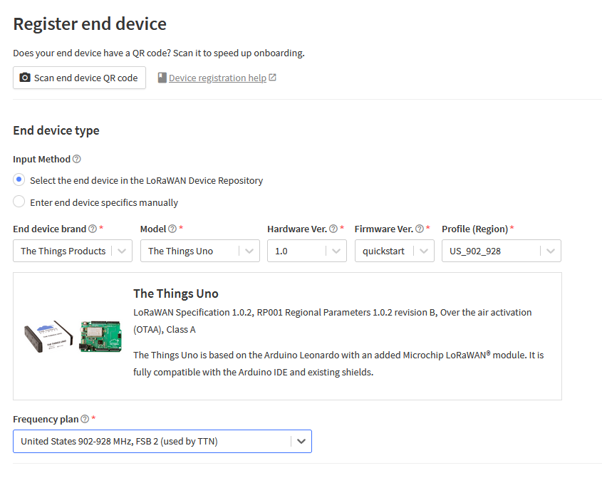

For the **Provisioning Information**:

JoinEUI - All 0’s

DevEUI - From Arduino Configuration Script

AppKey - Generate

End Device ID - Write a unique one, suggested format: **4id3-groupa-devicea**

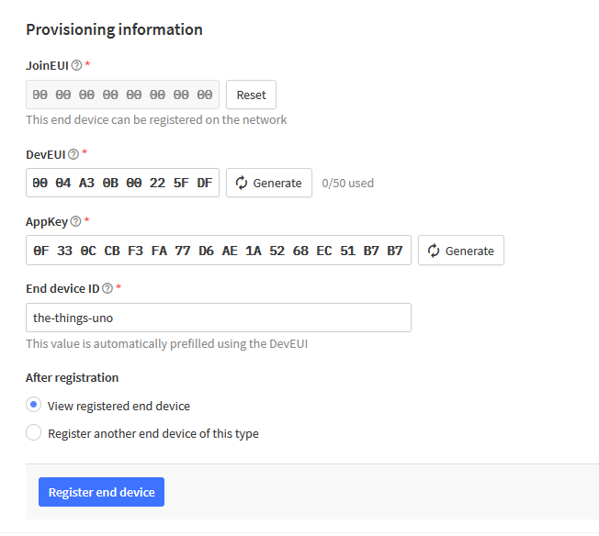

Press **Register End Device**.

|  |
| --- |
|  |

Note down your **APPEui** and **APPKey**. You will need these values for your **Field Device** to connect to The Things Network.

## Field Device

Make the following connections on your **The Things Uno** development board:

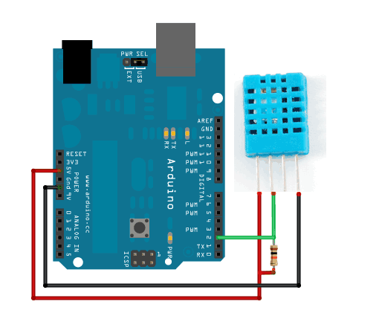

*DHT11 VCC -> Things Uno +5V*

*DHT11 GND -> Things Uno GND*

*DHT11 Signal -> Things Uno DIO 2 PWM*

Create a new Arduino project called **Lab04A** in your **4ID3/Lab04** folder. Name the project **FieldDevice**.

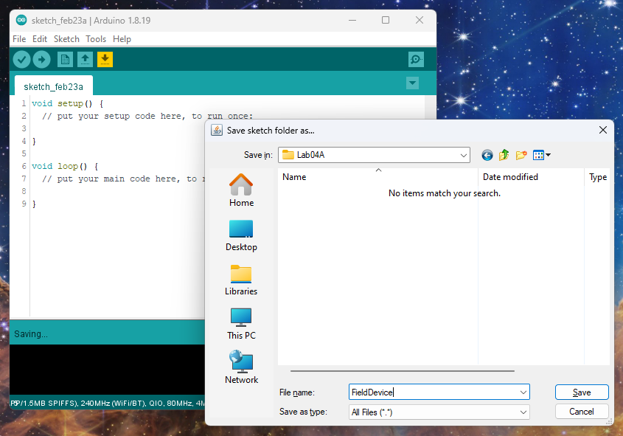

Create a new header file called **FieldDevice.h**. Here, we’ll store all the project configurations for easy access.

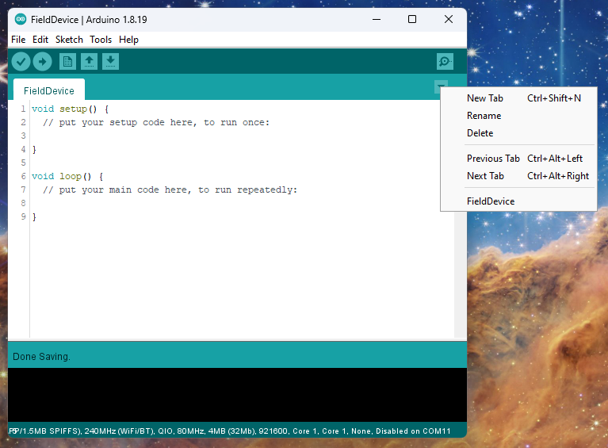

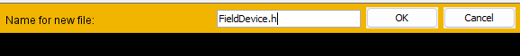

Include your libraries.

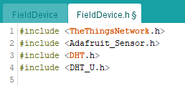

Next, we need to configure what digital pin our DHT11 sensor will be connected to.

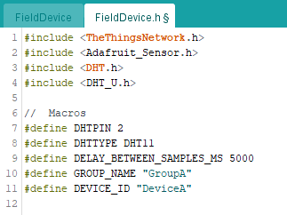

Next, lets instantiate the DHT object and provide a macro to differentiate the different serial objects in use.

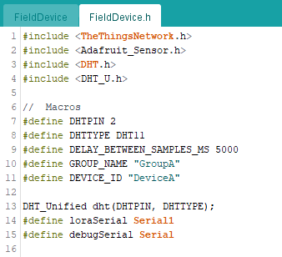

Configure your APP EUI and APP Key.

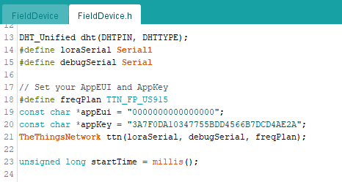

In the implementation file, include your header file.

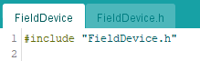

Next, set up your **setup()** function as such:

And once the specified interval has elapsed, poll your DHT11 sensor for temperature and humidity.

Reinterpret this data as a string with 2 decimal points.

Concatenate together a JSON formatted object containing your data.

Iteratively copy the string to a new character array.

Publish the character array to your LoRaWAN Things Stack Application.

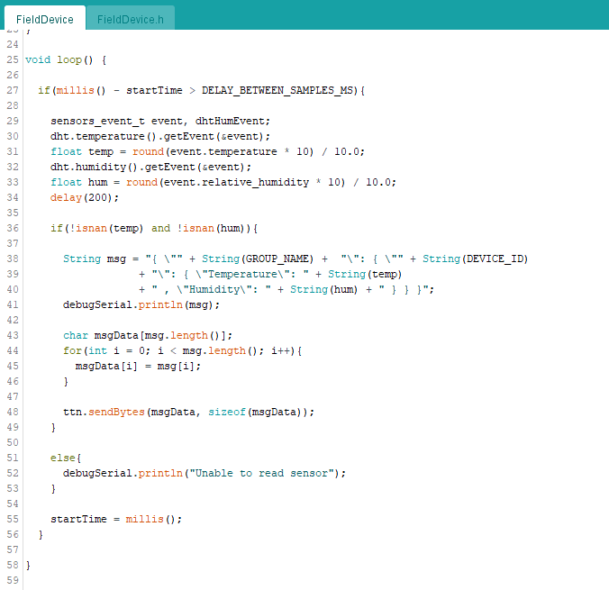

Build and upload your project to your **Arduino Leonardo** (The Things Uno) board and open your **serial monitor**.

If you receive **Unable to read sensor**, check your connections.

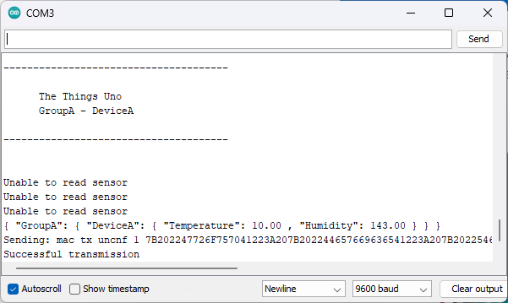

Navigate to your **Application > End Device** on **The Things Stack**, and verify that you are receiving data **uplinks**.

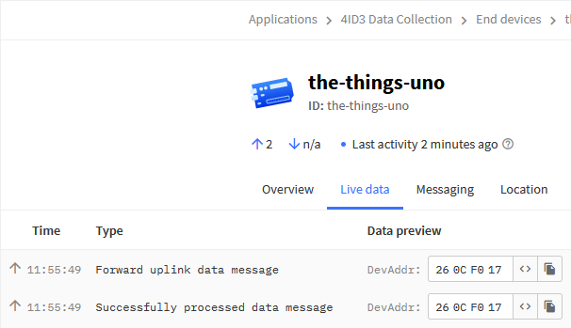

We structured our message in the following JSON format:

*{ “GroupA”: { “DeviceA”: { “Temperature”: 22.4 , “Humidity”: 42 } } }*

Because of this, we need to use JavaScript to parse the data in our Things Stack Application.

First, we need to tell the device to use the **Application Uplink Formatter**.

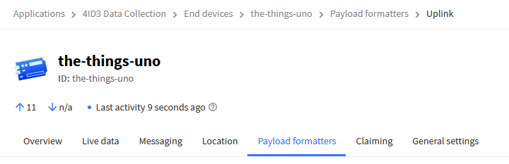

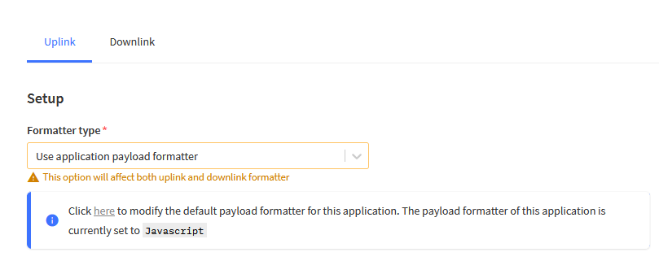

Ensure that you save changes.

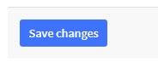

Next, navigate to your Application’s Uplink Formatter.

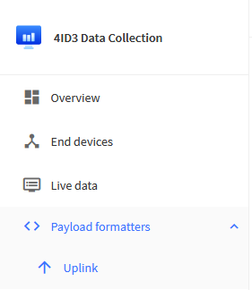

Configure to parse the JSON object.

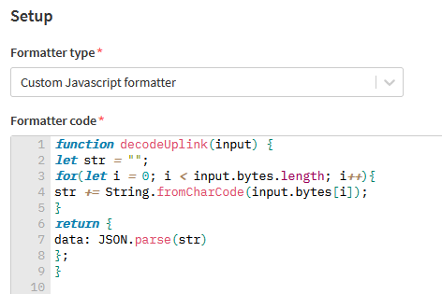

*function decodeUplink(input) {*

*let str = "";*

*for(let i = 0; i < input.bytes.length; i++){*

*str += String.fromCharCode(input.bytes[i]);*

*}*

*return {*

*data: JSON.parse(str)*

*};*

*}*

Press **Save changes**.

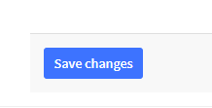

Navigate back to **Live data** and view the data streams.

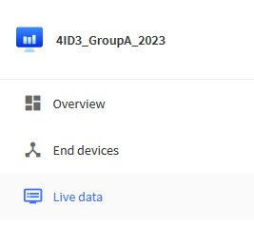

View the uplink.

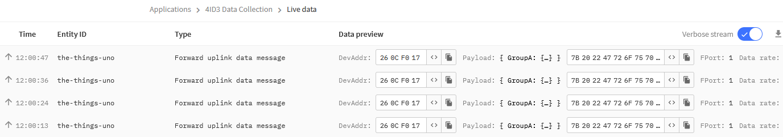

**Click** on the **most recent uplink** to view the entire JSON encoded uplink.

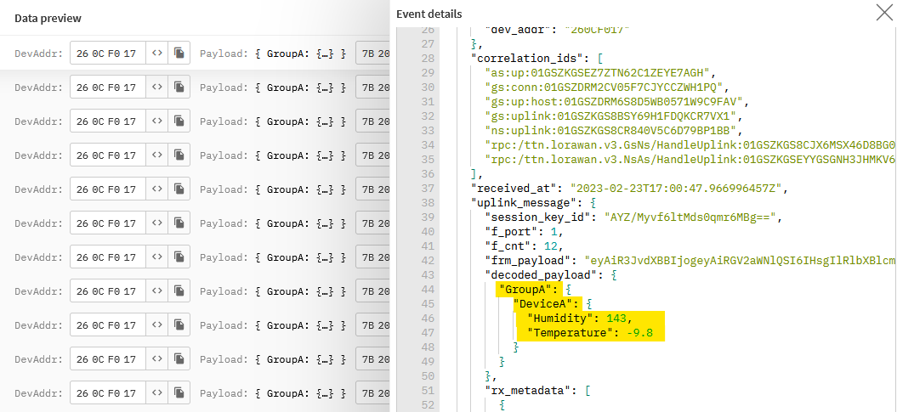

Notice that your data is in the **uplink_message/decoded_payload** field.

# MQTT Integration

Click on **Integrations > MQTT** in the **Application Menu**.

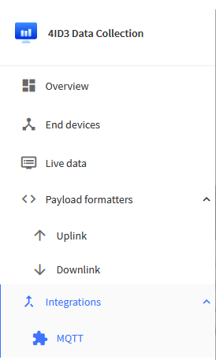

Click **Generate new API key**.

Copy these 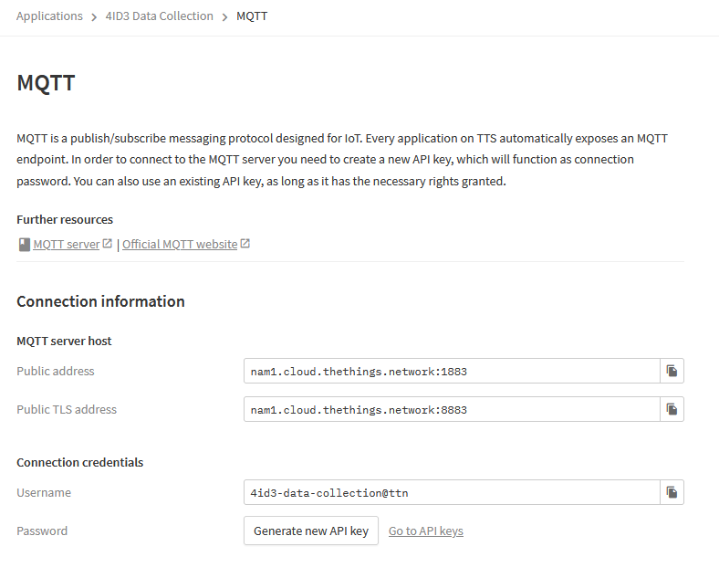

Copy these credentials into a nodepad file.

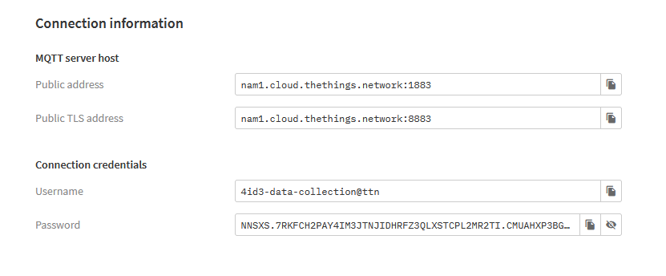

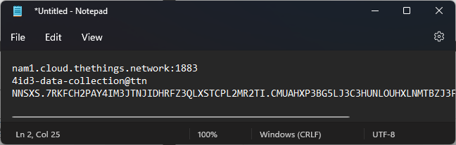

Using **a chromium based browser**, install the extension named **MQTTBox**.

<https://chrome.google.com/webstore/detail/mqttbox/kaajoficamnjijhkeomgfljpicifbkaf/related?pli=1>

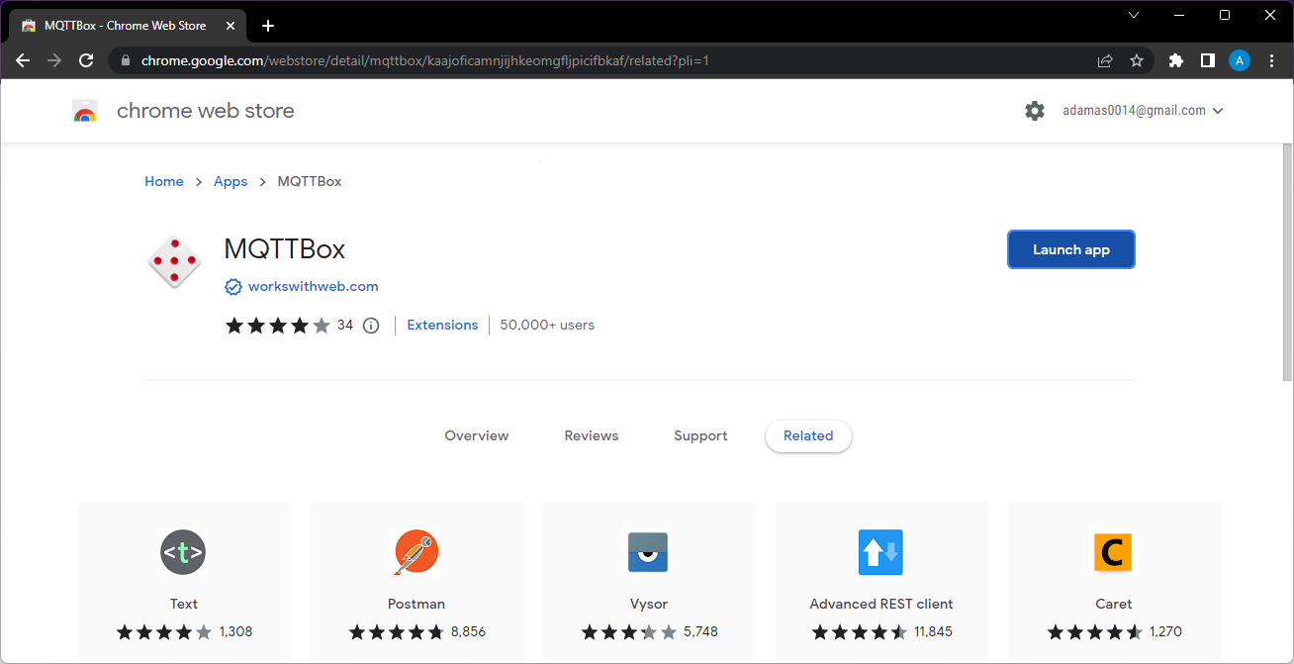

Launch **MQTTBox**.

Copy the information from the MQTT Integrations page to connect to The Things Network MQTT server.

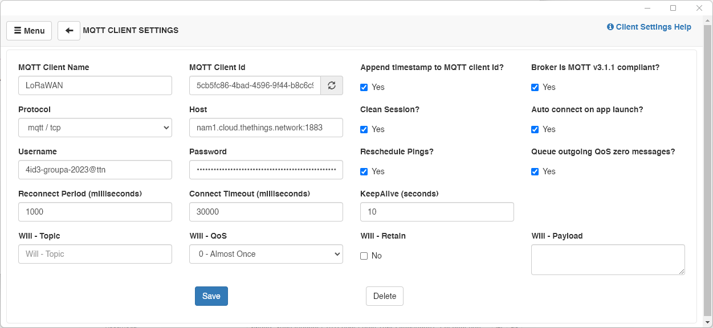

*Client Name = <Anything>*

*Protocol = mqtt / tcp *NOTE: this is not secure, for security in the real world, use mqtt / tls.*

*Username: <The username you copied>*

*Host = <The host URL you copied>*

*Password = <The API key you copied>*

Press **Save**.

Ensure that you connect after a few seconds. If not, verify your credentials are correct.

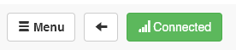

Click **Add Subscriber**.

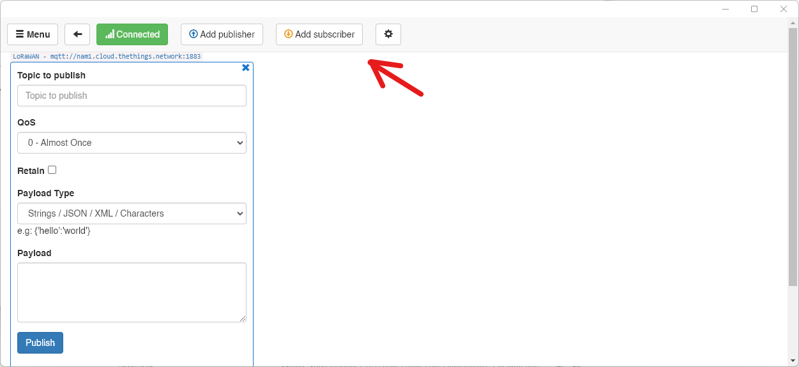

Subscribe to the topic **#** , which means **all**. Press **Subscribe**.

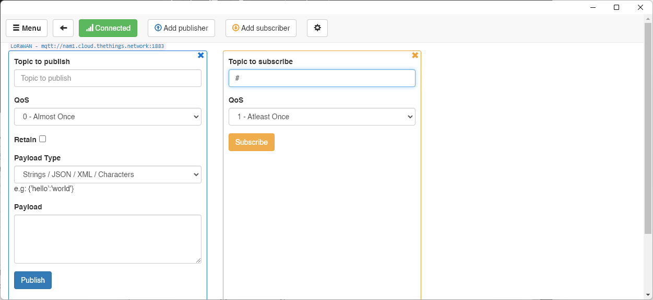

Watch as the data populates in your MQTT subscription.

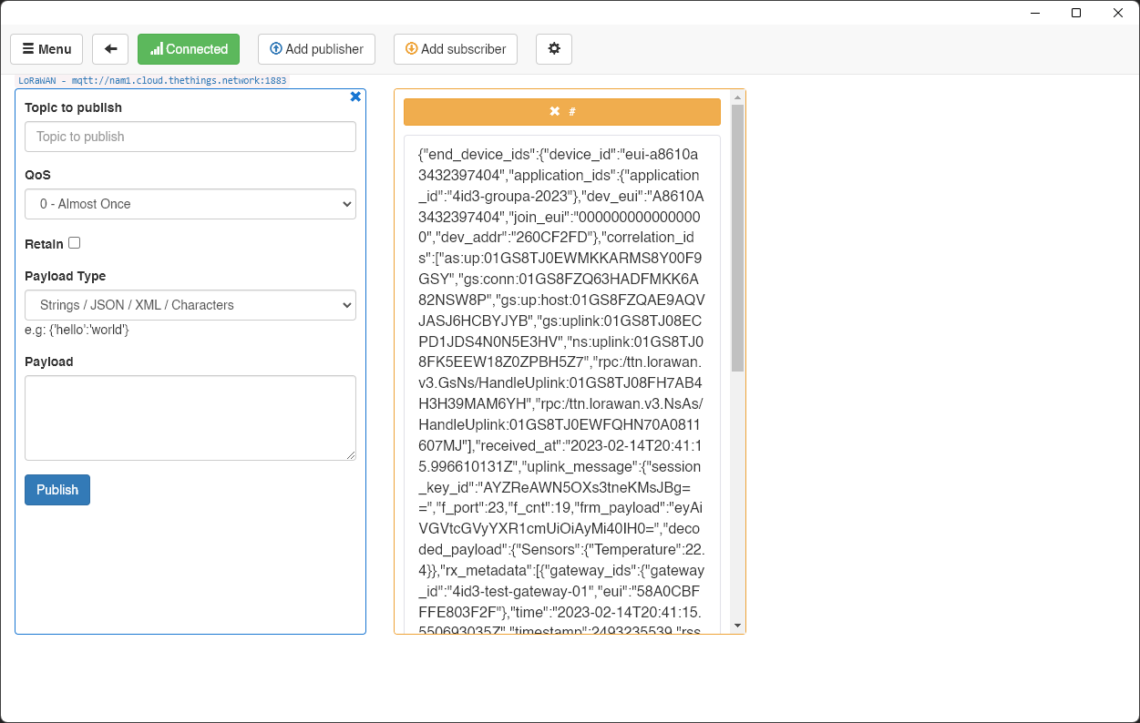

# Data Collection and Analysis

Its amazing that we can see our sensor data in MQTT, but seeing everything may be overwhelming and it isn’t useful to see it in a raw format like this when building an IoT network. We need to implement a way to:

1. Store the data
2. Visualize the data

For storing the data, we’ll switch it up from previous weeks. Instead of using a MongoDB database, we will use a MySQL database, which is a **relational database**. Non-relational databases are really good for quickly dumping data into without worrying about the relationship between the data. Meanwhile relational databases are more common because they are **very specific** on how they store data, and they can be parsed **extremely quickly** using commands called **SQL Queries**. There is an entire diagram format called an **ERD (Entity Relationship Diagram)** which describes these relationships.

This lab will only **demonstrate** how to use SQL queries in an **IoT application**. Further study will be required to master it.

## Installing MySQL & MySQL Connector

Navigate to the following web page and download the MySQL Installer. Install the **second** option.

<https://dev.mysql.com/downloads/installer/>

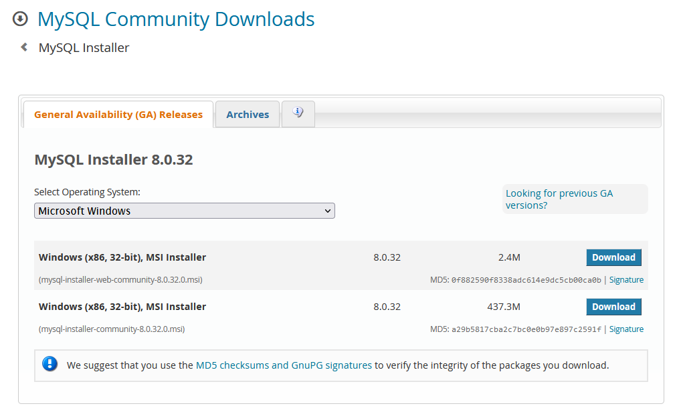

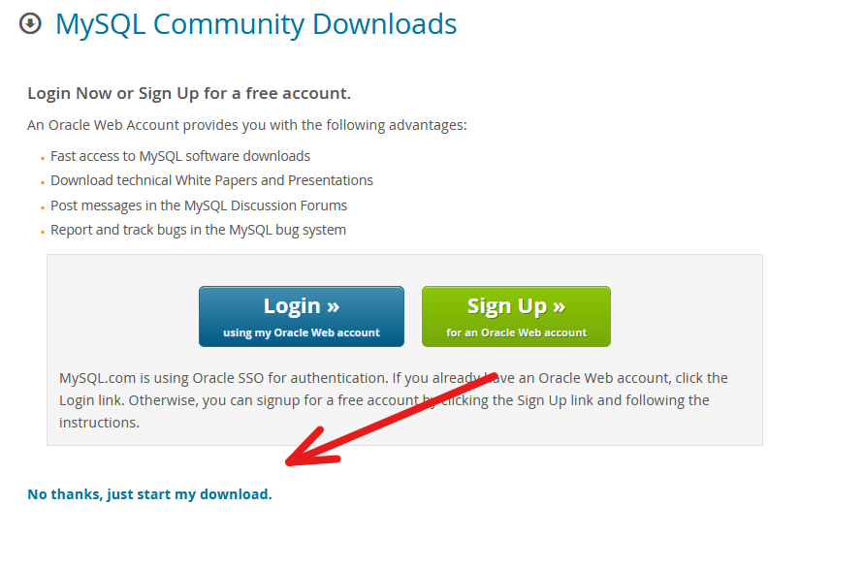

**Run** the installer. It will prompt for **Administrator** privileges.

Select **Full**.

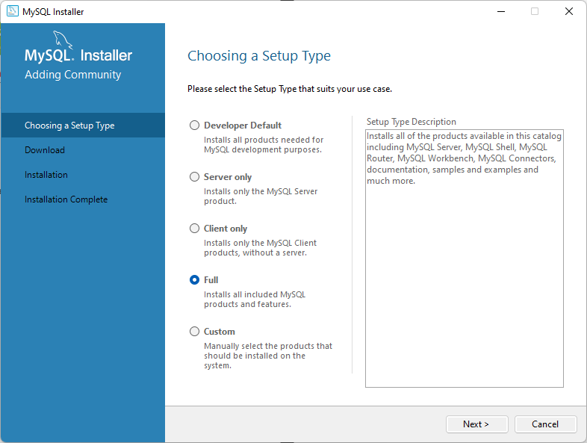

Select **MySQL Workbench**.

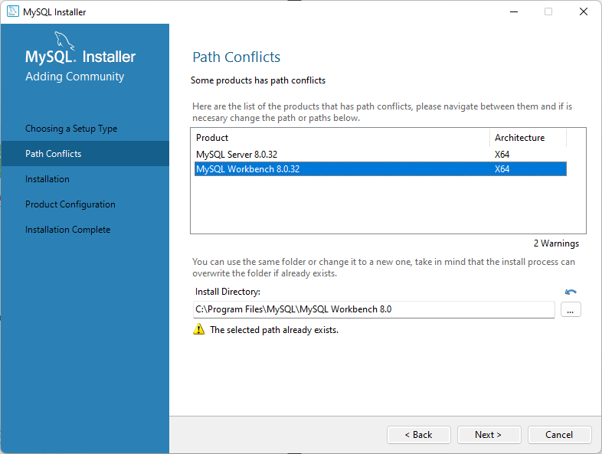

Press **Execute**.

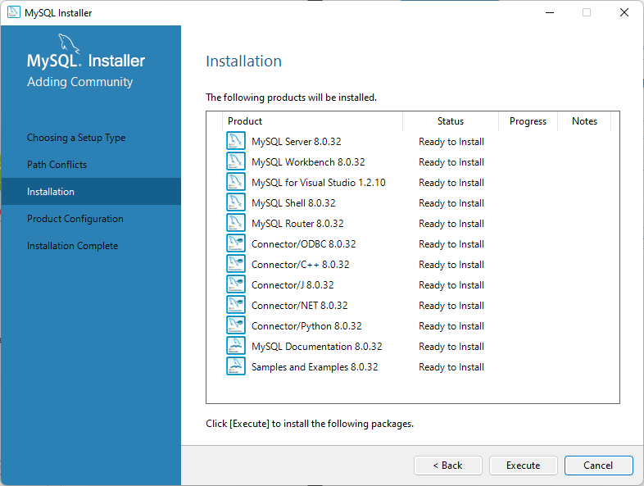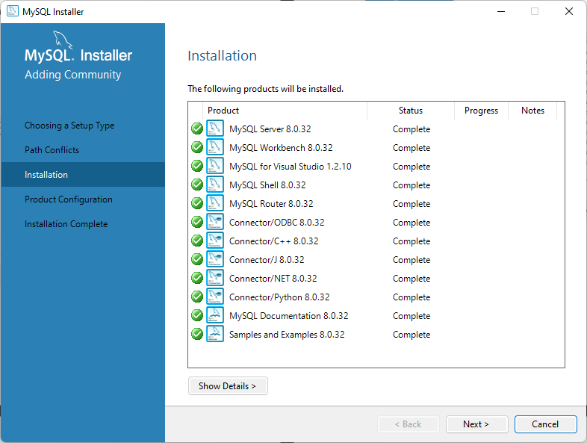

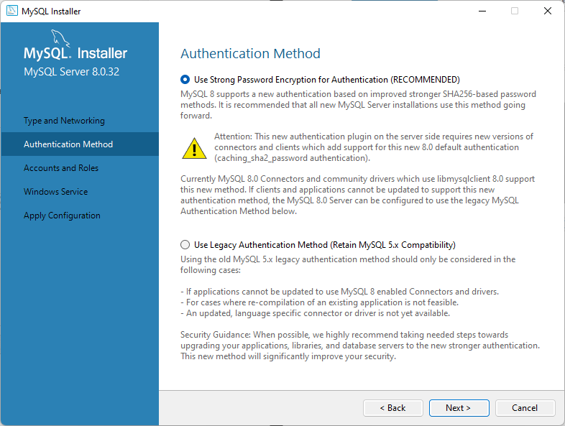

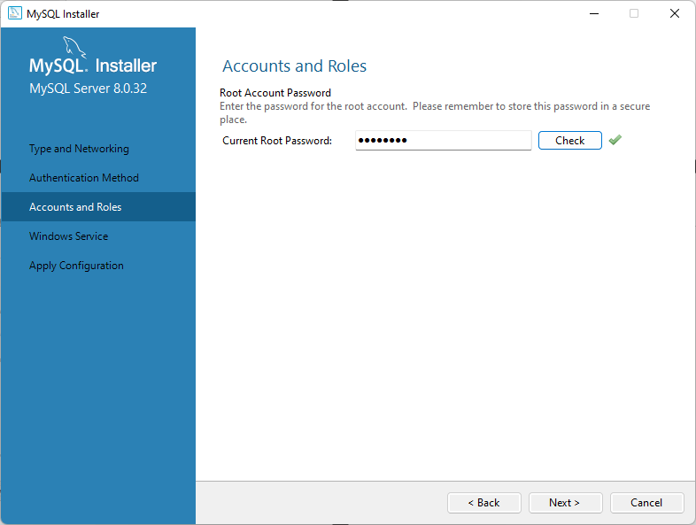

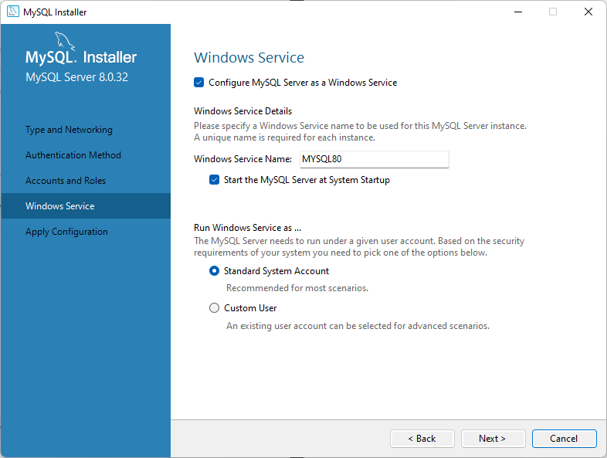

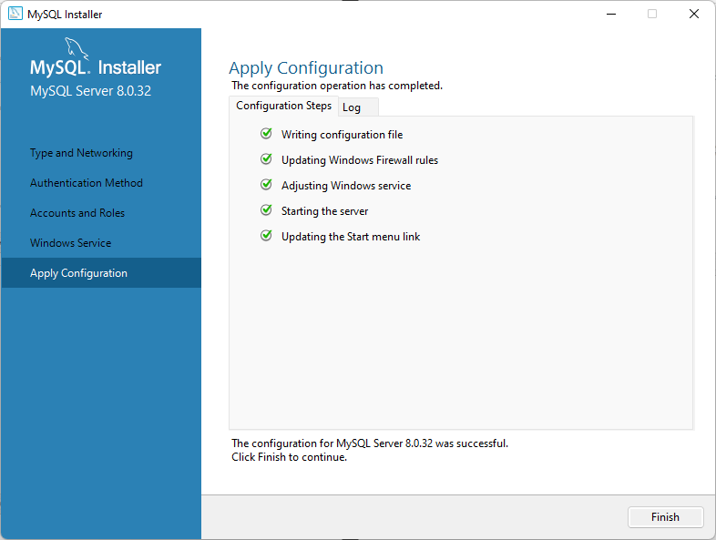

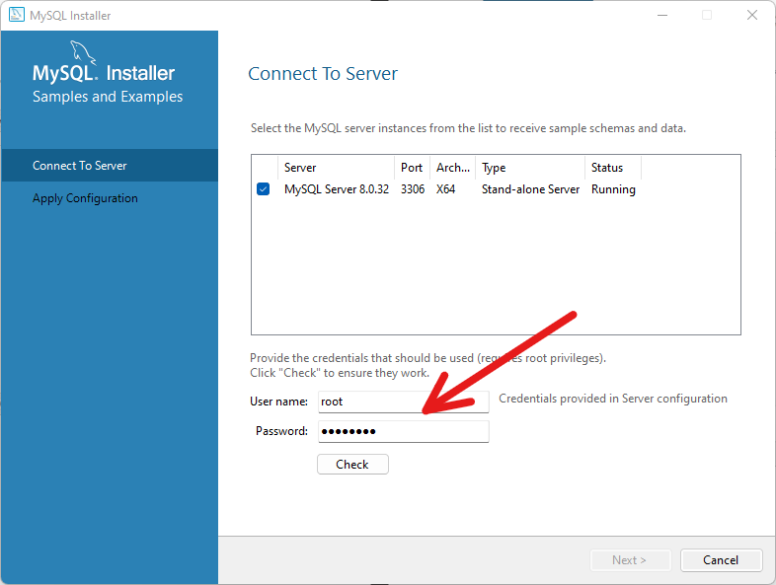

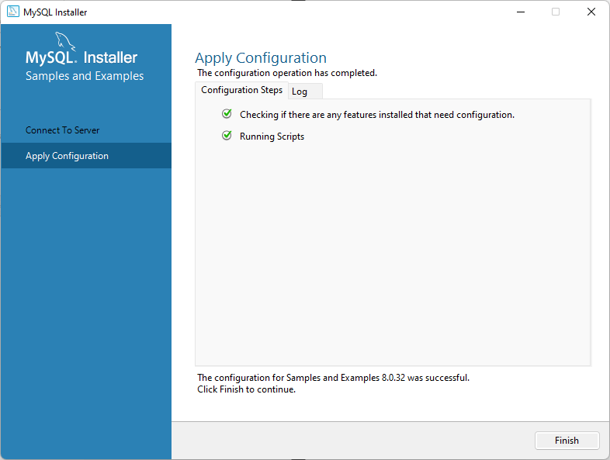

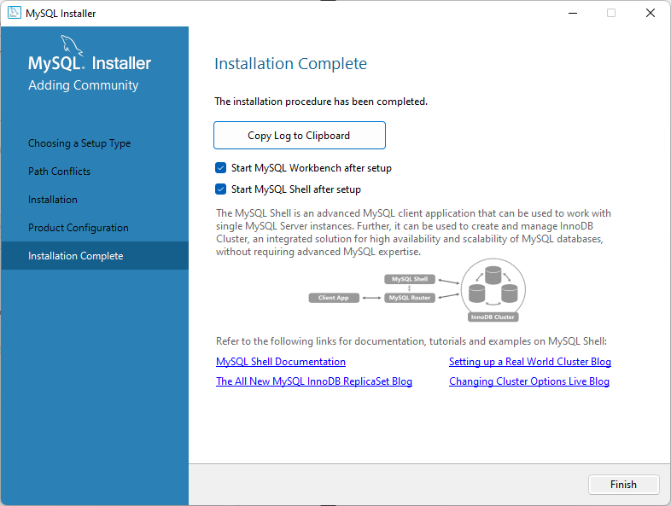

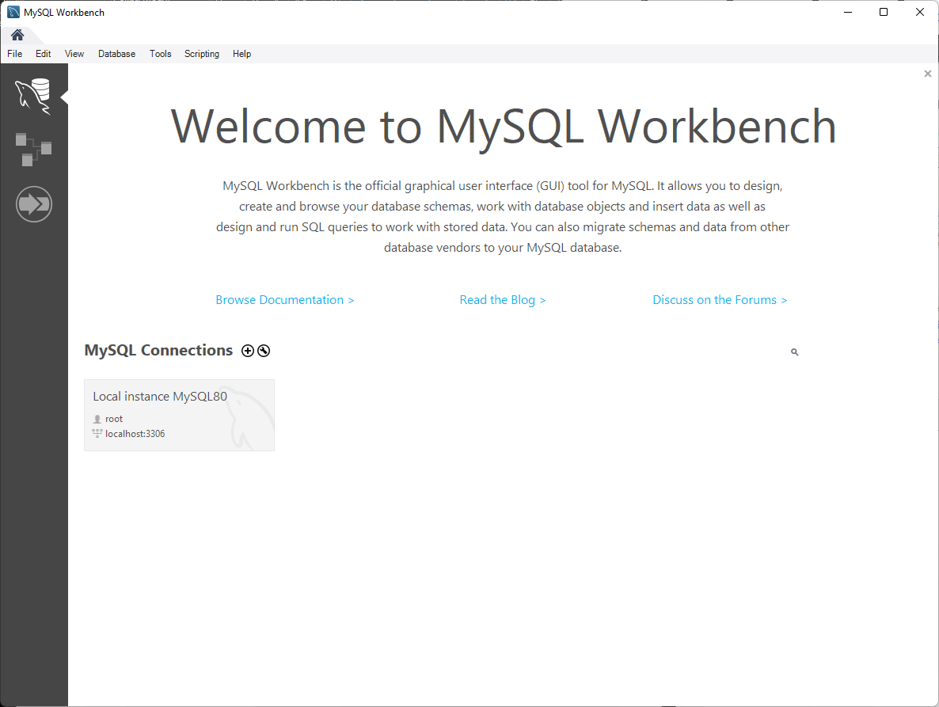

# Exercise A

Create a **NodeRED** flow to parse the MQTT message and graph it on your dashboard. Include a screenshot with your report. Save your flow to your GitHub.

*HINT:*

*For this challenge, you will need to add a* ***Function Node*** *into your* ***flow*** *that instead of returning* ***msg.payload****, it returns* ***msg.payload.uplink_message.decoded_payload.GroupA.DeviceA.Temperature****. Plug this function block into your* ***graph*** *node.*

[*https://nodered.org/docs/user-guide/messages*](https://nodered.org/docs/user-guide/messages)

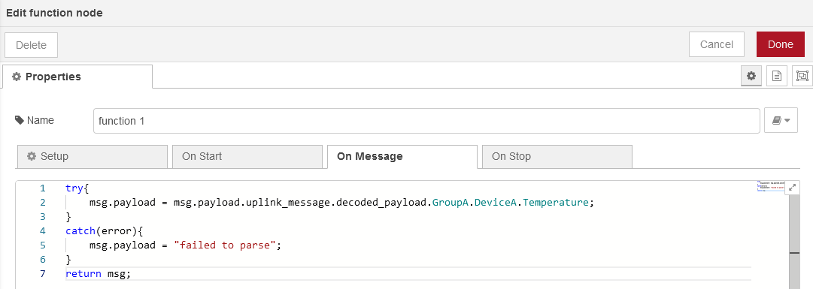

# Data Collection

## Python Virtual Environment

Open the **4ID3/ folder** using **VSCode**.

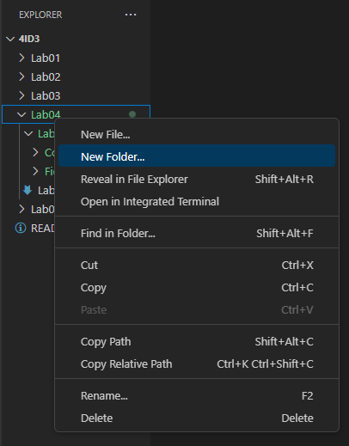

Name it **Lab04B**.

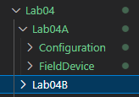

Unlike in previous labs, today we are not going to install Python libraries globally on our PC using PIP. Instead, we are going to create a **Python Virtual Environment** (VENV).

This wasn’t done in previous labs to keep things simple as many people are at different levels of understanding when it comes to python.

However, if you work on python projects in the future, this is how it should be set up for each project.

Create another folder inside of **Lab04B** called **scripts/.**

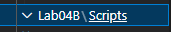

Navigate into this folder and run the command:

*python -m venv venv*

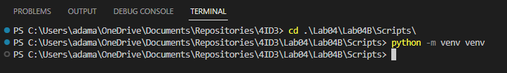

Notice that many files have been created.

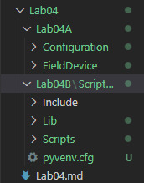

If you received an error, run the following using pip in PowerShell as Administrator and try again:

*pip install virtualenv*

You have now created an isolated python environment in your PC. Libraries that were installed previously have no impact here, and libraries installed here have no impact on your PC.

To use this environment, you must source the **venv/Scripts/activate.bat** script.

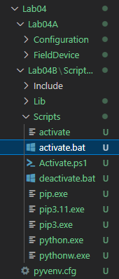

To start using this **virtual environment**, you must first source the **activate.bat** file in **each new teminal window.**

*.\venv\Scripts\activate*

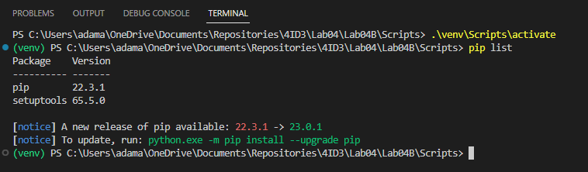

Notice how only 2 python packages are installed in this environment.

Go ahead and upgrade pip as recommended.

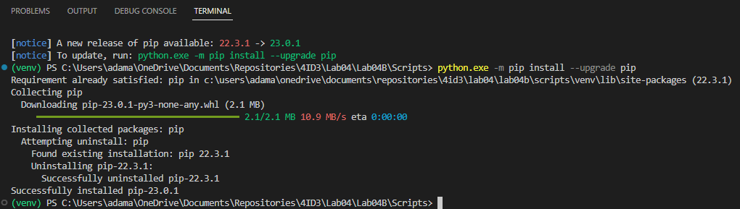

From here, while in the virtual environment, please install the following packages using pip:

*pip install mysql-connector-python*

*pip install paho-mqtt*

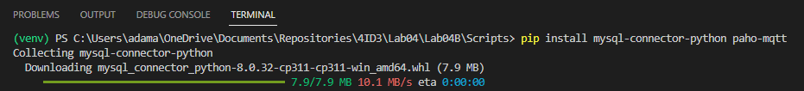

Now, so other people can install these packages in one easy command, we’ll generate a **requirements.txt** file.

*pip freeze > requirements.txt*



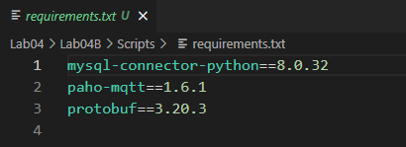

To load packages from this file, use the following command:

*pip install -r requirements.txt*

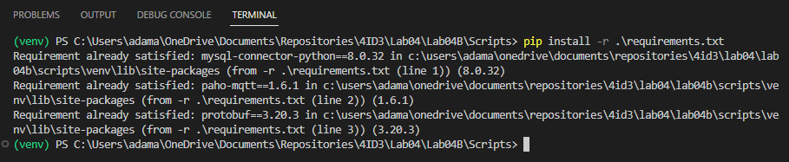

Now copy the following **Python scripts** from the **lab GitHub repo** into **Lab04/Lab04B/Scripts**:

* Config.py
* CreateDatabase.py
* MQTT2MySQL.py
* MySQL2Excel.py
* MySQLSimpleParser.py
* MySQLAdvancedParser.py

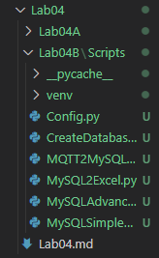

Open **Config.py** and enter your **individual credentials**. These credentials will be imported into every other Python file.

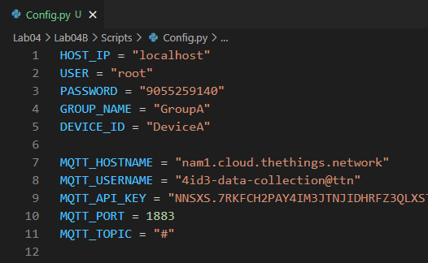

## Creating the Database

Once completed, run the **CreateDatabase.py** script from the terminal. Ensure that you have your venv sourced.

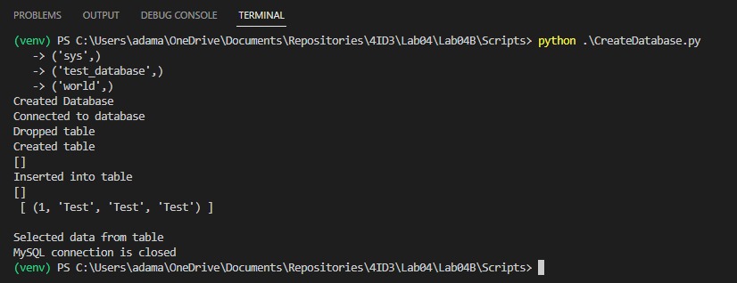

To verify that the database has been generated, open **MySQL 8.0 Command Line Client**.

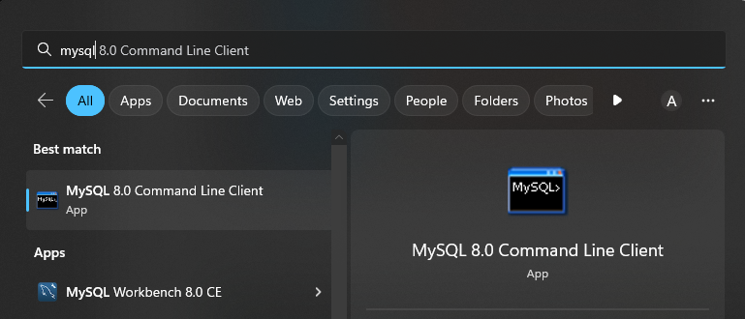

Enter your password and issue the following queries. Ensure that the test insert was successful.

USE *`GroupA`*

*SELECT * FROM `GroupA`.`DeviceA`;*

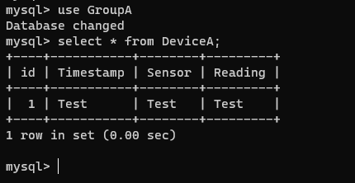

From here, we can also try an insert directly.

*INSERT INTO `GroupA`.`DeviceA` (`Timestamp`, `Sensor`, `Reading`) VALUES (‘Test2’, ‘Test2’, ‘Test2’);*

*SELECT * FROM `GroupA`.`DeviceA`;*

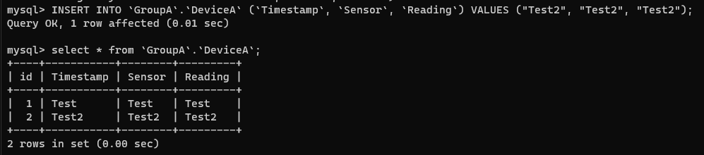

## Converting Database to Excel

Next, using the VSCode terminal, launch **MySQL2Excel.py**.

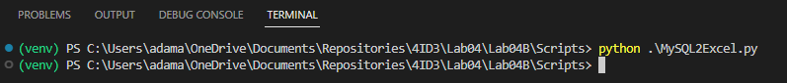

Observe that a new file has been generated.

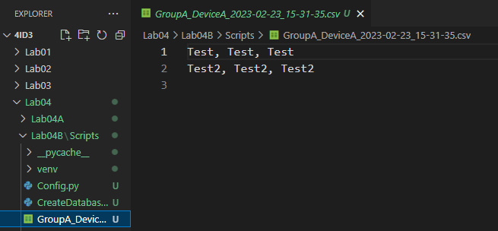

## Connecting MQTT to your Local MySQL Database

Ensure that your **Field Device** is still publishing data and launch **MQTT2MySQL.py**.

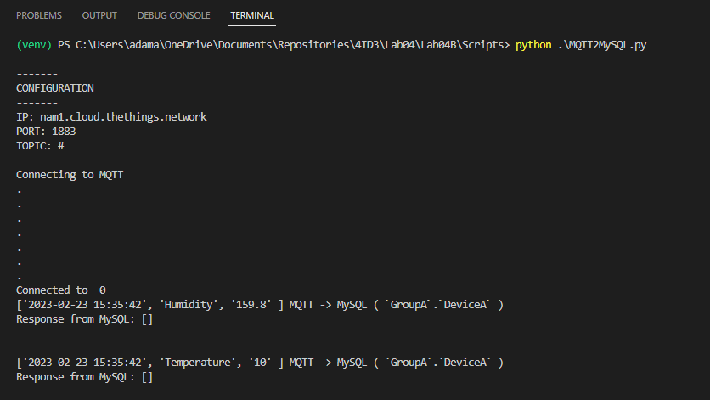

Ensure that they are being inserted correctly.

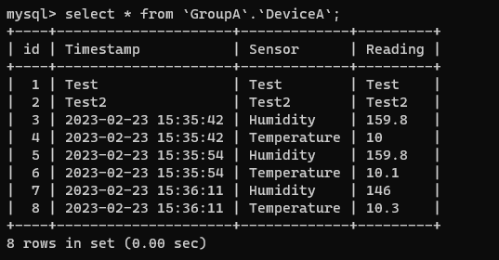

## Parsing the Database (Simple)

Run the **MySQLSimpleParser.py** script then, using a **web browser**, navigate to **localhost:3000**.

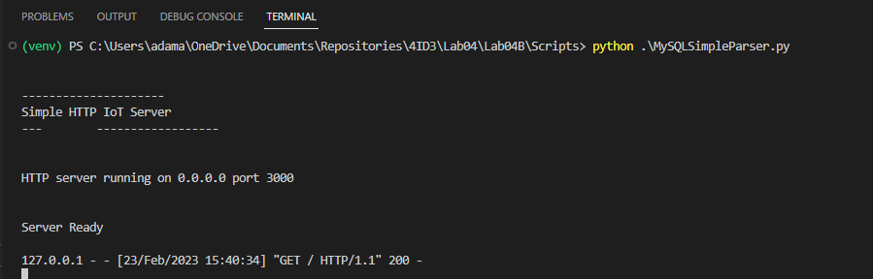

Each time the page is reloaded, a GET request is sent to the HTTP server. During the callback function of the GET request, the database is queried for new data and this new data is formatted as an HTML document and server to the client’s web browser.

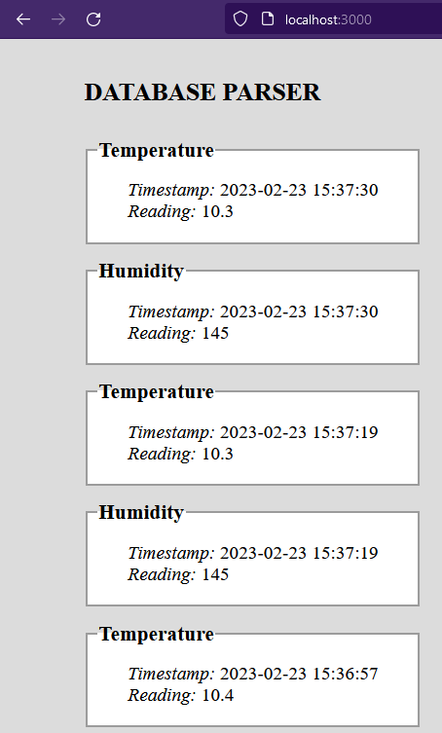

## Parsing the Database (Advanced)

Run the **MySQLAdvancedParser.py** script then, using a **web browser**, navigate to **localhost:3000**.

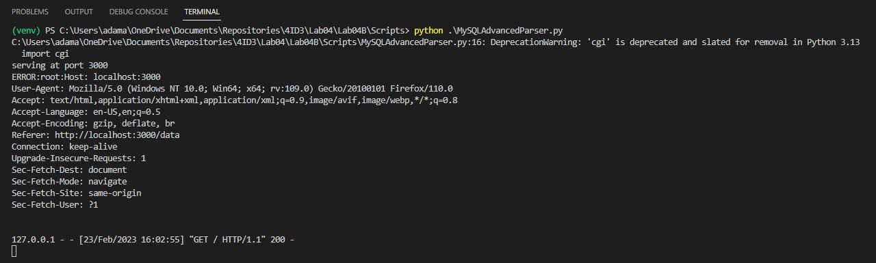

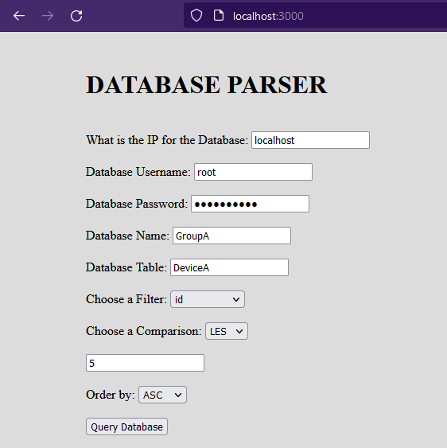

Choose your parameters and press **Query Database**.

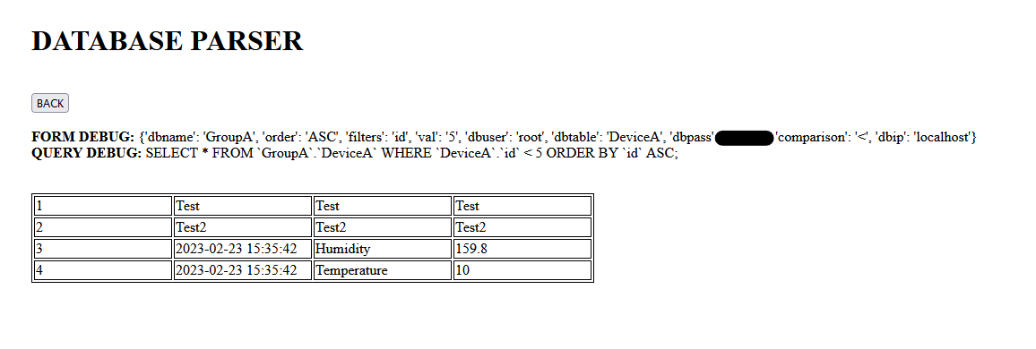

A table should be automatically generated based on your entered parameters.

# Exercise B

Use **Microsoft Excel** to graph the data **queried** from your database (*MySQL2Excel.py*). Paste the graph with your lab submission.

# Installing Visual Studio

In this section, we will explore creating a basic desktop form application that connects to MySQL and uses the IoT data that has been collected in previous sections.

Desktop apps are an alternative to the web applications built in the previous section. Instead of a web server serving your web browser an HTML document with sensor data, a desktop application is a program specifically compiled for your computer. In our case, as a .EXE file which runs on Windows.

We will be learning the basics of 1-page form applications in C# using .NET WinForms, and gathering user data to create database queries.

Don’t be intimidated by C#. It has a similar syntax to C++ and you’ll be led through the entire process. If you wish to use a desktop application in your project, or are just interested in learning more, I strongly suggest on watching a few YouTube videos.

Navigate to the Microsoft Visual Studio download page.

<https://visualstudio.microsoft.com/downloads/>

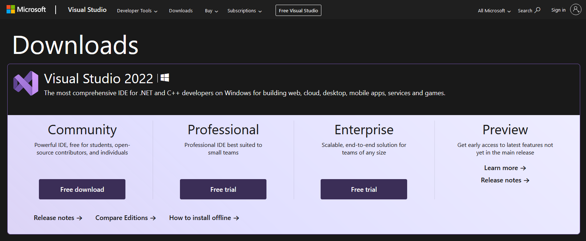

Click **Free download** for the **Community** edition and run the **installer**.

Ensure that **.NET desktop development** is checked on the **Workloads** menu. Press **Install**.

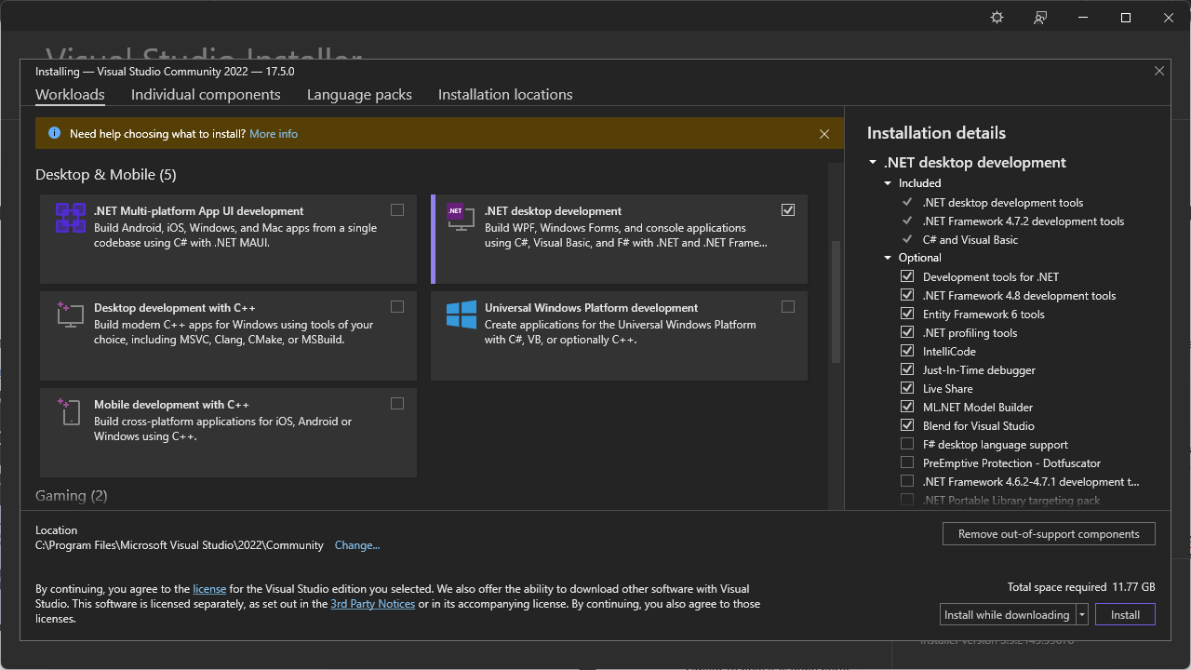

The install process will take 10 minutes.

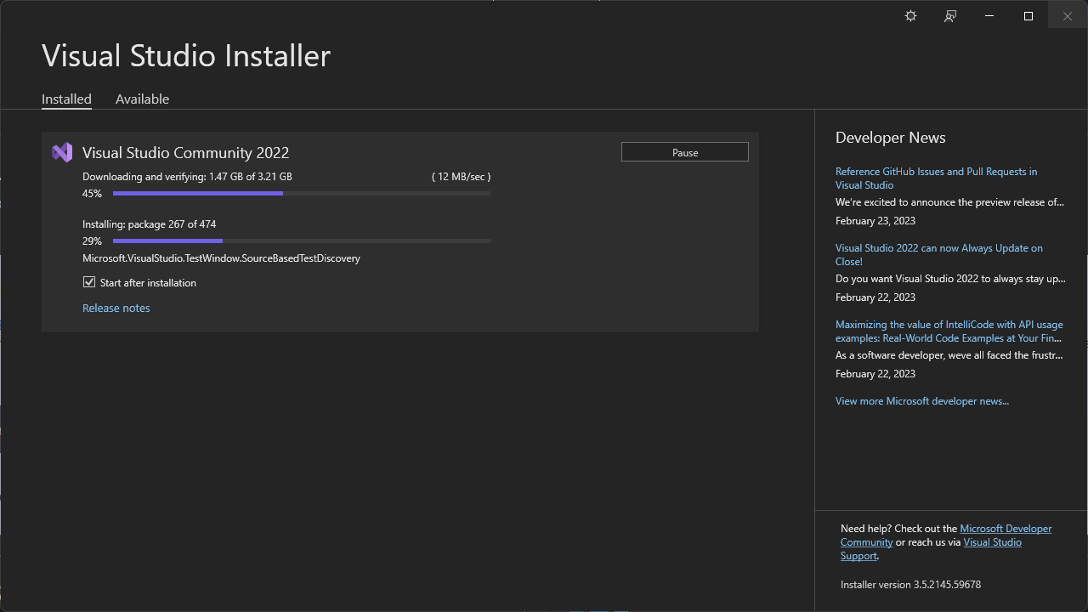

# Creating a WinForms Desktop Application

## Setup

Once the install is completed, **restart** your PC and launch **Visual Studio 2022**.

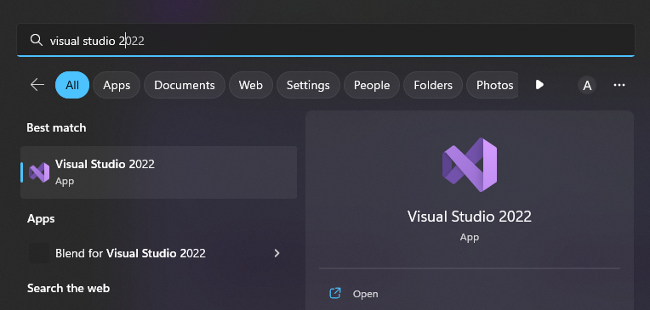

**Skip** creating an account or use your McMaster email.

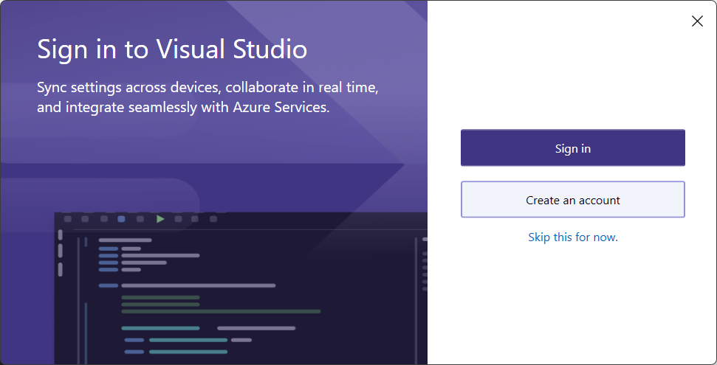

Select **Create New Project > Windows Forms App**.

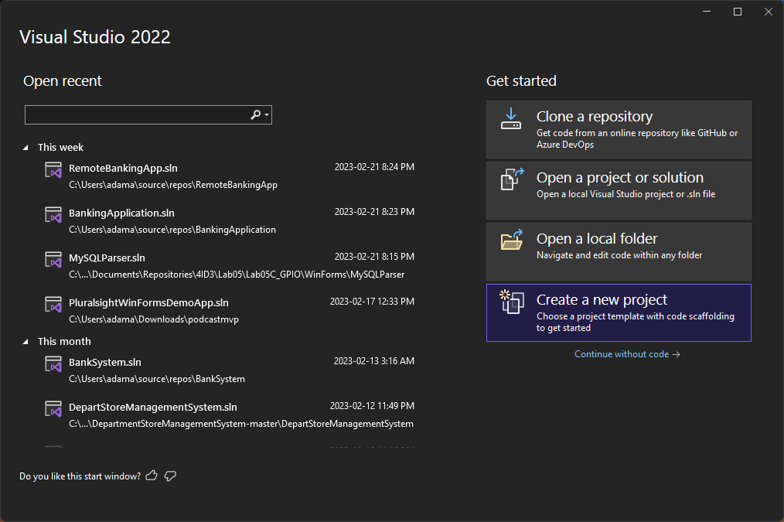

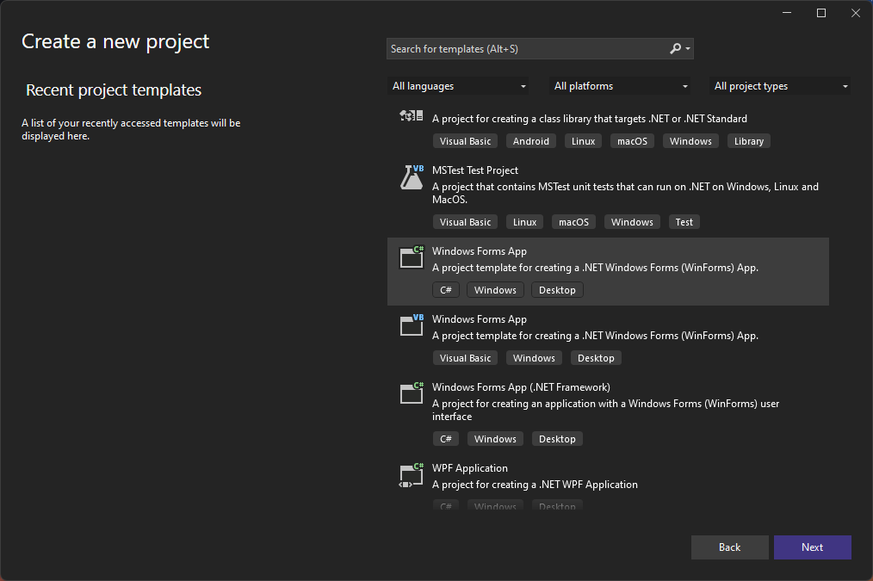

Save your **MySQLParser** desktop application inside of **Lab4B/**.

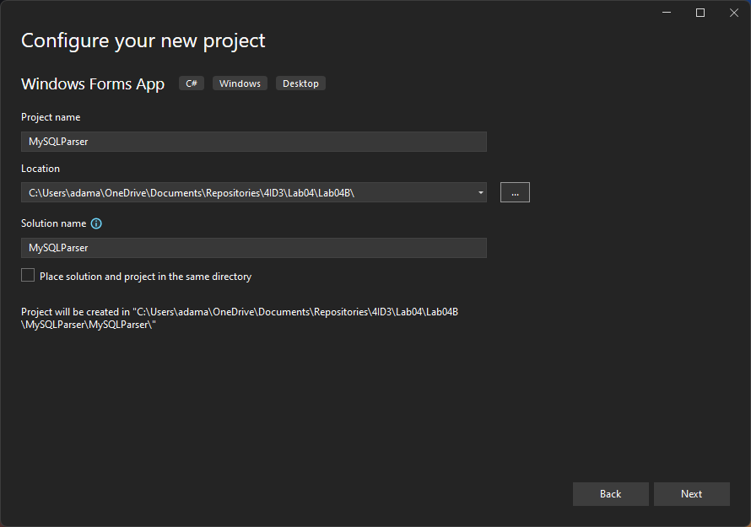

Use **.NET 6.0 LTS**. Press **Create**. It will load for **20 seconds**.

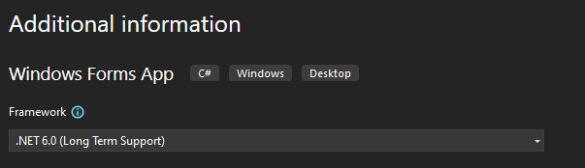

You will be visited by an empty project interface.

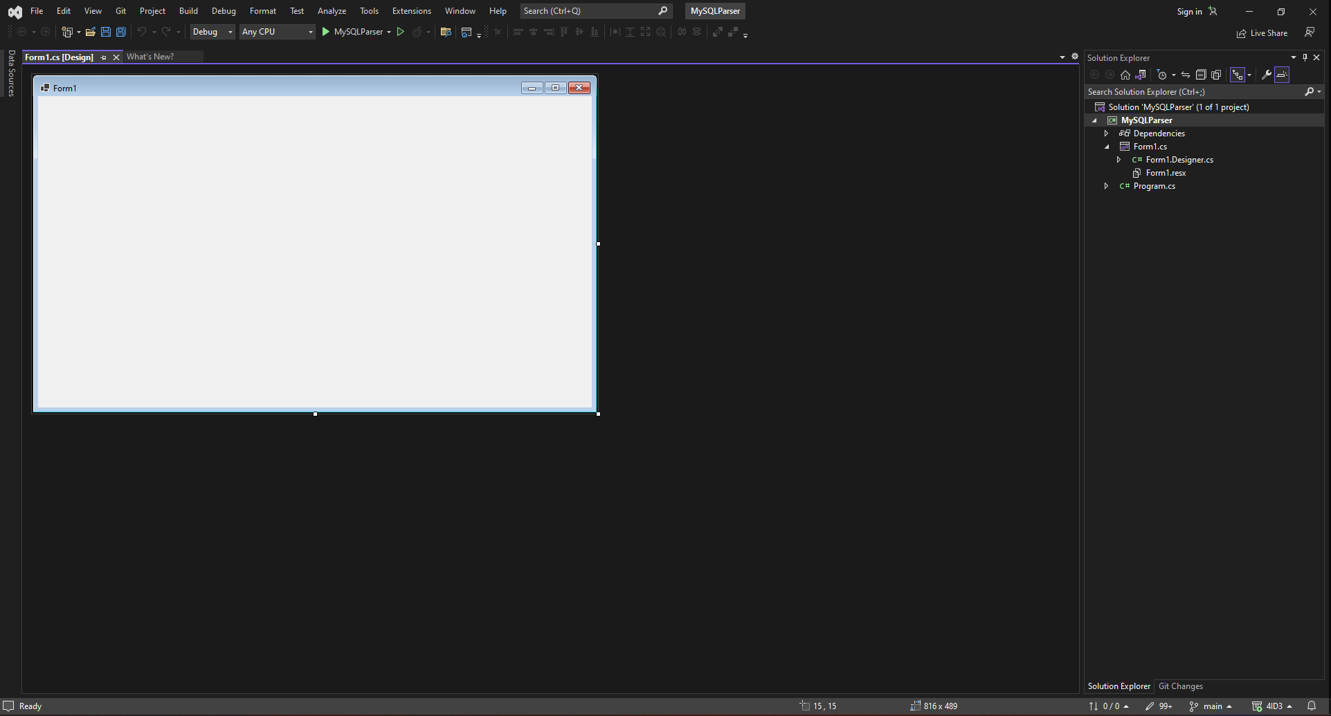

Firstly, **double-click Form1** to open the code editor.

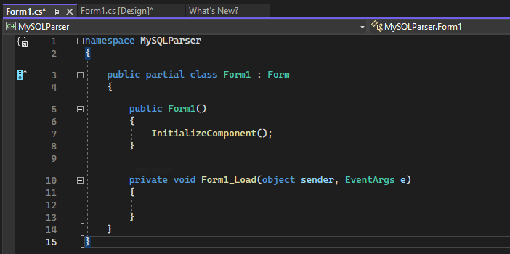

Navigate to **View > Toolbox** to open the toolbox.

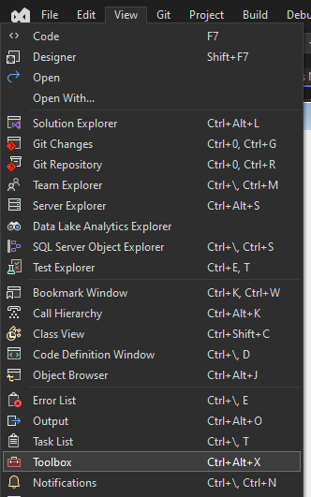

## Adding Elements

Search **text** and drag a **textbox** into your **Form1**.

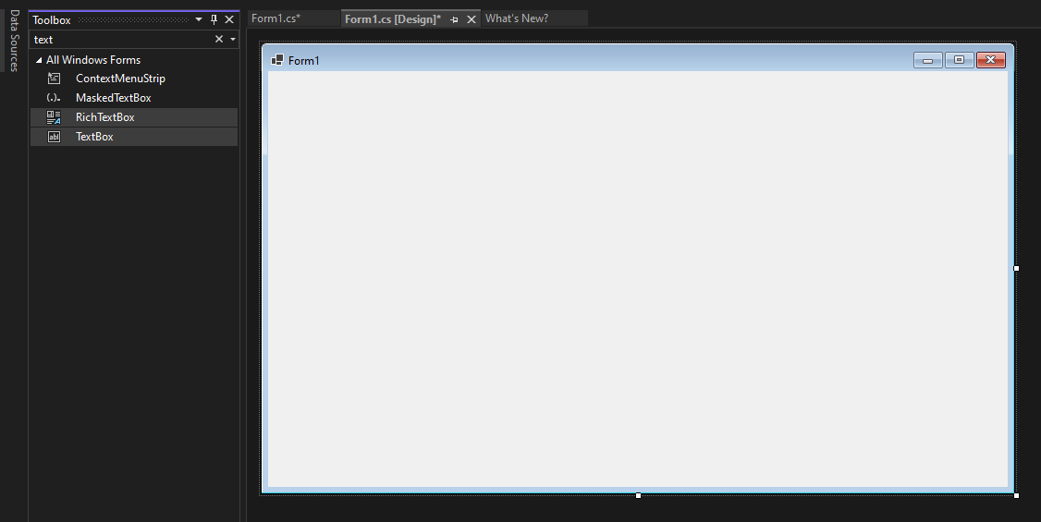

Next, we need a **label** to tell the user what this text box is for. Search and drag a **label** into your **Form1.**

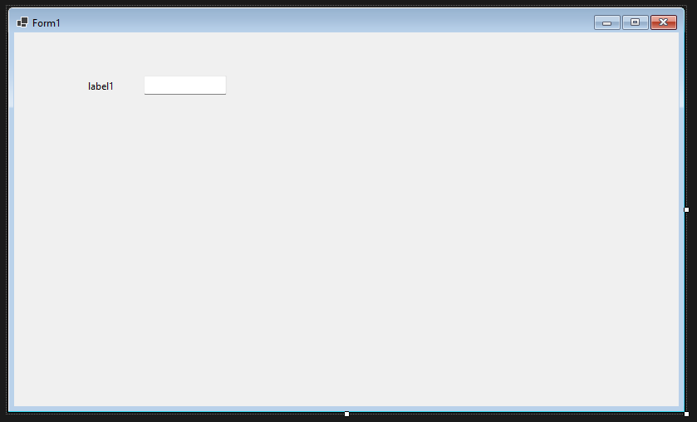

To open the **Properties** **editor**, **right click** on an element and select **Properties**.

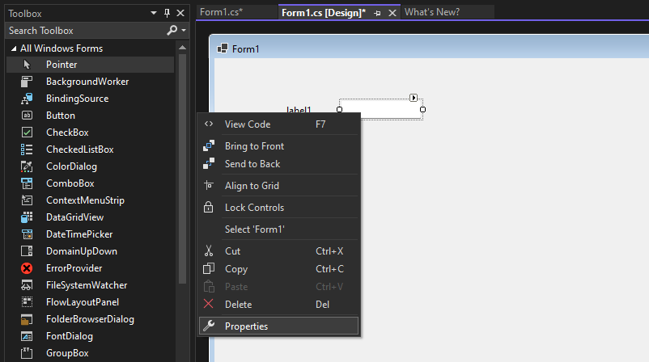

A new window should appear on the **right.**

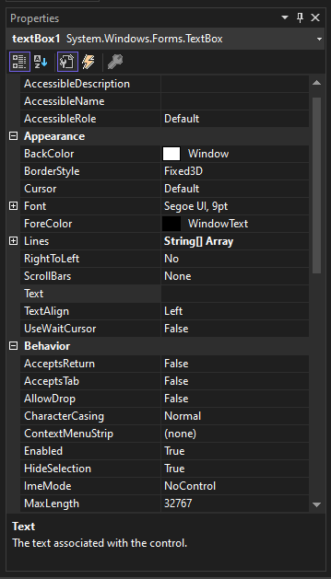

Modify the **Design > (Name)** property to be **txt_DatabaseIP**. This is the value that we will use to reference this object in the code.

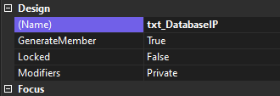

Next, click on your **label** and set the **Design > (Name)** property to **lbl_DatabaseIP**.

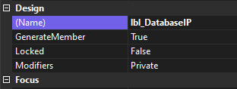

Finally, the **Appearance > Text** property and set it to **Database IP**. This changes what the label says.

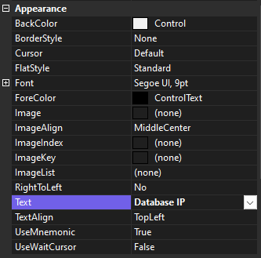

**Search** for a **button** and drag it into **Form1**.

Change its **Design > (Name)** property to **btn_QueryDatabase**.

Change its **Appearance > Text** property to **Query Database.**

**Search** for a **Data Grid View** and drag it into **Form1**.

Change its **Design > (Name)** property to **grid_DataView**.

**Click** on the **Form1** blue window.

Change its **Design > (Name)** property to **MySQLParser**.

Change its **Appearance > Text** property to **MySQLParser**.

You should have this:

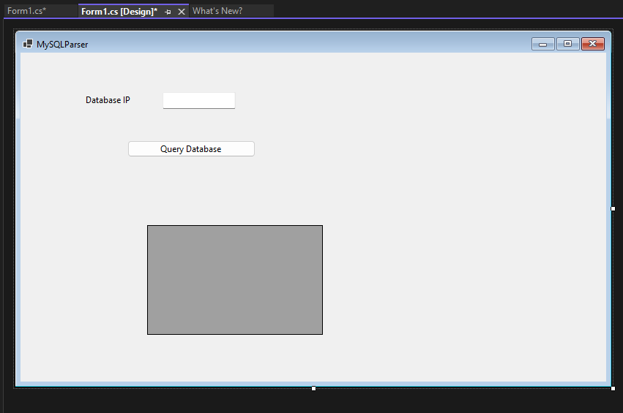

Following the previous steps, add more txt and lbl to create the following app:

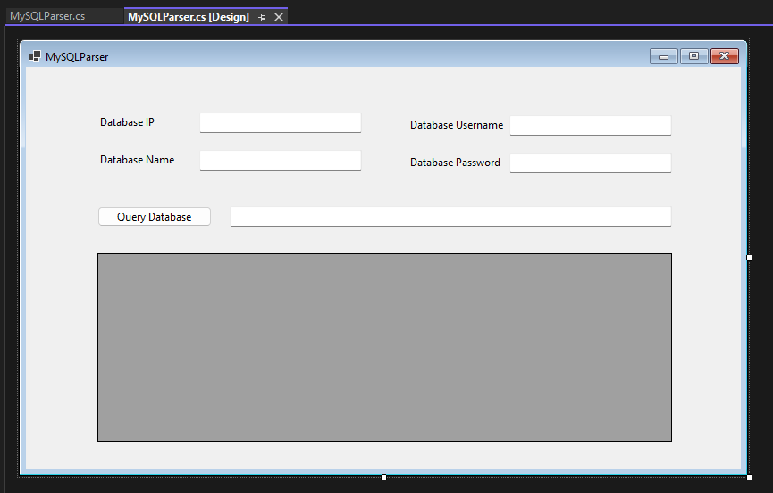

**Double-click** the **Query Database button** to auto-generate the **callback function**. You should be automatically taken to the **MySQLParser** class.

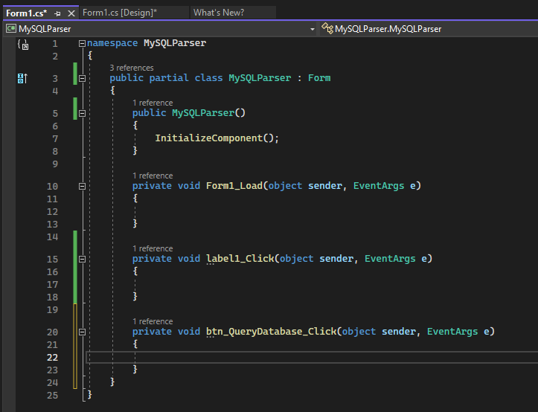

## Installing NuGet Packages

In your **Solution Explorer**, **right click** on your project and select **Manage NuGet Packages**.

NuGet is a package manager, like pip is for Python.

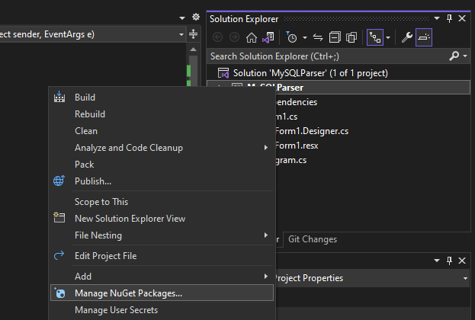

In the **Browse** tab, search **MySQL Oracle** and select **MySql.Data** by Oracle. Click **Install**.

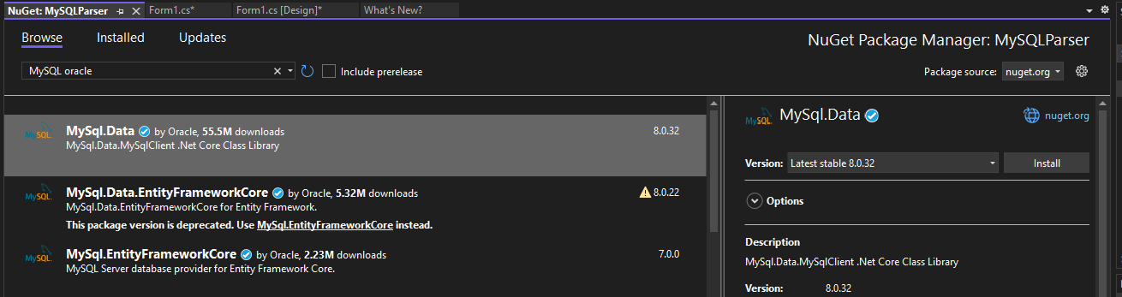

Back in your **code**, add the installed MySql package.

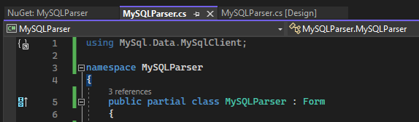

## Creating a Database Model

Inside of your **MySQLParser form class**, create a class named **DBModel**.

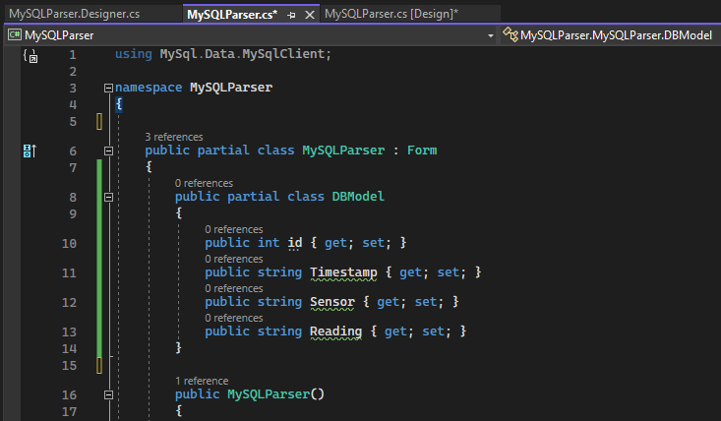

In the onClick callback method for your **Query Database button**, start off by using the MySql library to establish connection with your database by concatenating the provided data to a connection string.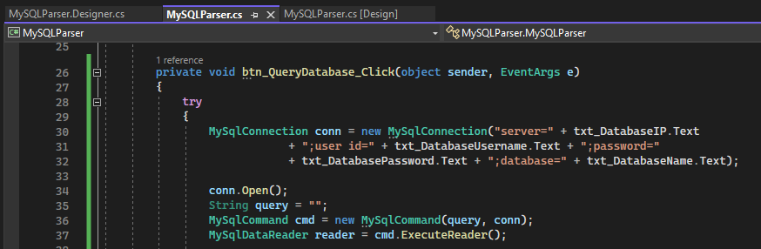

Next, create an instance of your database model and parse the data retrieved from the database.

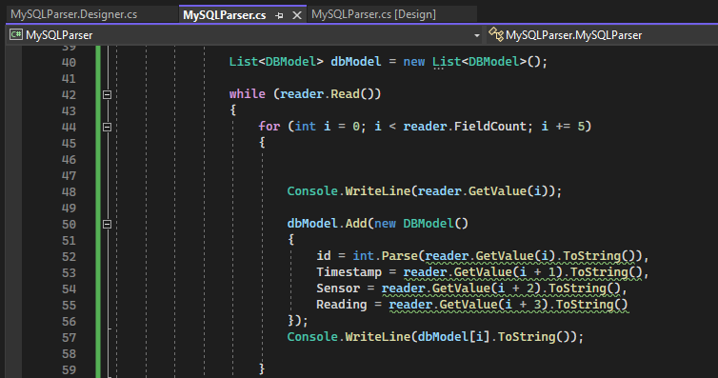

Finally, bind the model to your **Data Grid View** and close your **try/catch** block.

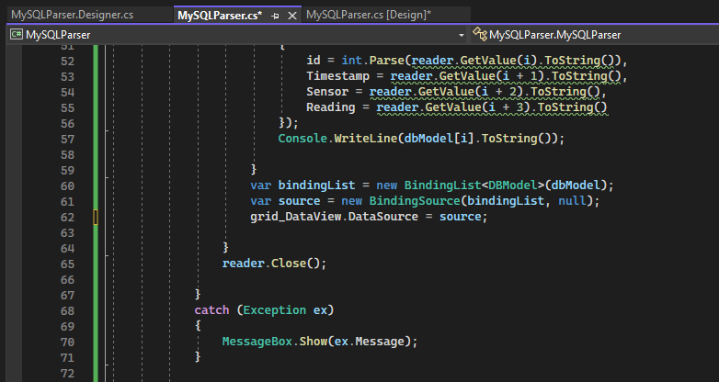

Full code:

using MySql.Data.MySqlClient;

using System.ComponentModel;

namespace MySQLParser

{

public partial class MySQLParser : Form

{

public partial class DBModel

{

public int id { get; set; }

public string Timestamp { get; set; }

public string Sensor { get; set; }

public string Reading { get; set; }

}

public MySQLParser()

{

InitializeComponent();

}

private void Form1_Load(object sender, EventArgs e)

{

}

private void btn_QueryDatabase_Click(object sender, EventArgs e)

{

try

{

MySqlConnection conn = new MySqlConnection("server=" + txt_DatabaseIP.Text

+ ";user id=" + txt_DatabaseUsername.Text + ";password="

+ txt_DatabasePassword.Text + ";database=" + txt_DatabaseName.Text);

conn.Open();

String query = txt_QueryDatabase.Text;

MySqlCommand cmd = new MySqlCommand(query, conn);

MySqlDataReader reader = cmd.ExecuteReader();

List<DBModel> dbModel = new List<DBModel>();

while (reader.Read())

{

for (int i = 0; i < reader.FieldCount; i += 5)

{

Console.WriteLine(reader.GetValue(i));

dbModel.Add(new DBModel()

{

id = int.Parse(reader.GetValue(i).ToString()),

Timestamp = reader.GetValue(i + 1).ToString(),

Sensor = reader.GetValue(i + 2).ToString(),

Reading = reader.GetValue(i + 3).ToString()

});

Console.WriteLine(dbModel[i].ToString());

}

var bindingList = new BindingList<DBModel>(dbModel);

var source = new BindingSource(bindingList, null);

grid_DataView.DataSource = source;

}

reader.Close();

}

catch (Exception ex)

{

MessageBox.Show(ex.Message);

}

}

}

}

Run your program in debug mode and test it out.

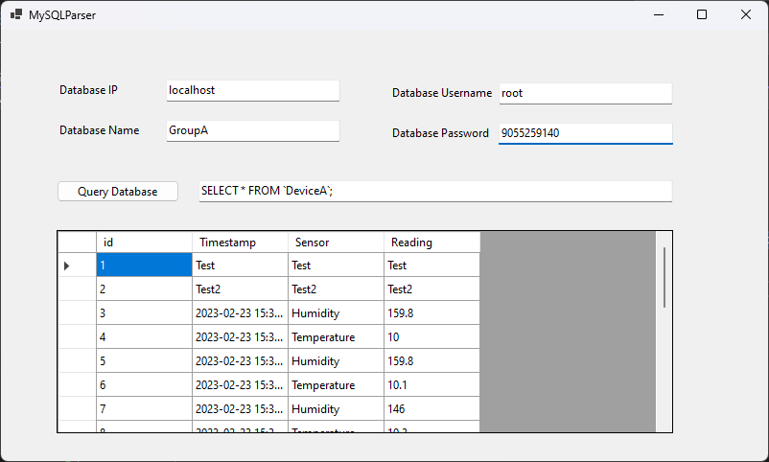

Lastly, lets build it in release mode.

Change your build configuration to **Release**.

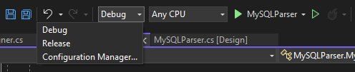

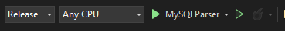

Right click on your project and select **Build Solution**.

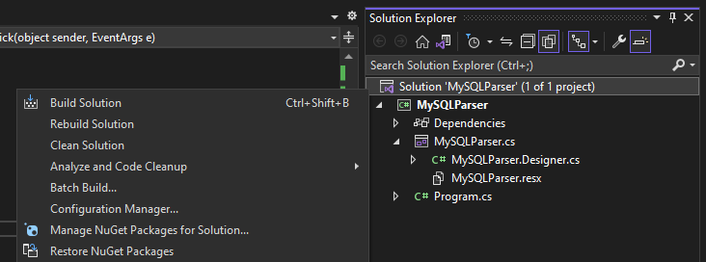

To find the built program, **right click** on your **Solution** in the **Solution Explorer** and click **Open Folder in File Explorer.**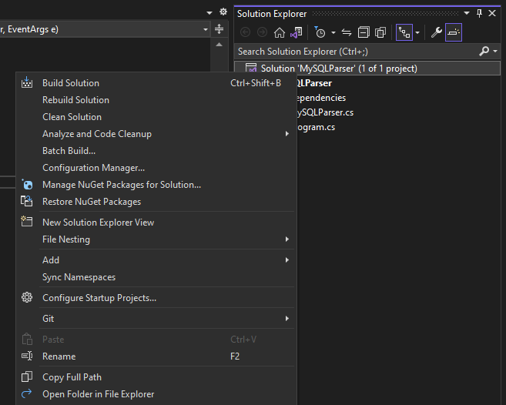

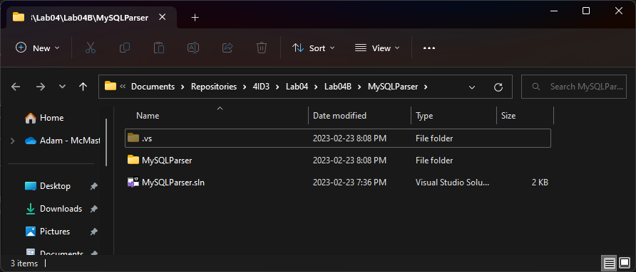

Navigate to **MySQLParser > bin > Release > net6.0-windows** and find **MySQLParser.exe**.

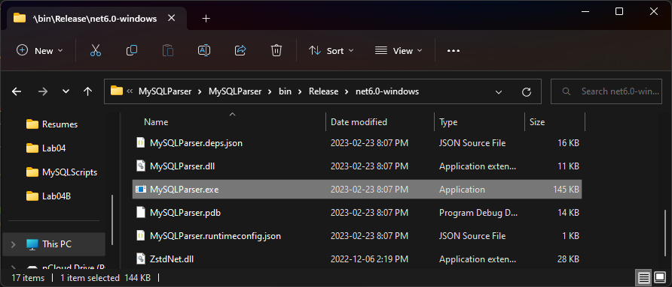

**Double click** to **run** the program.

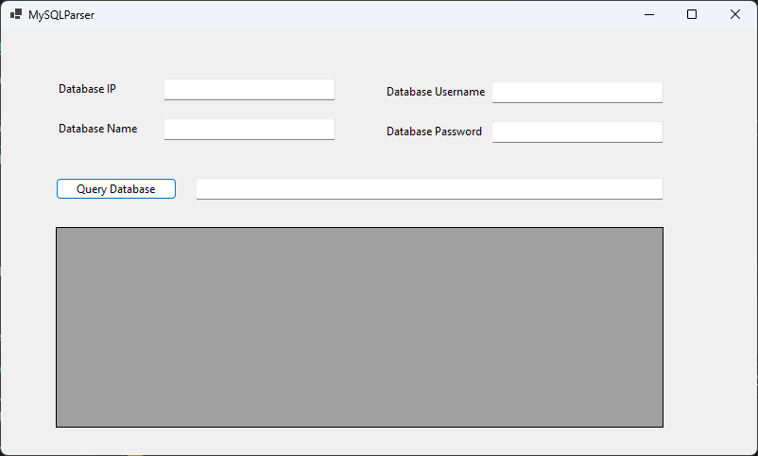

# Creating a WinForms User Interface

In this section, we will be making the following static interface:

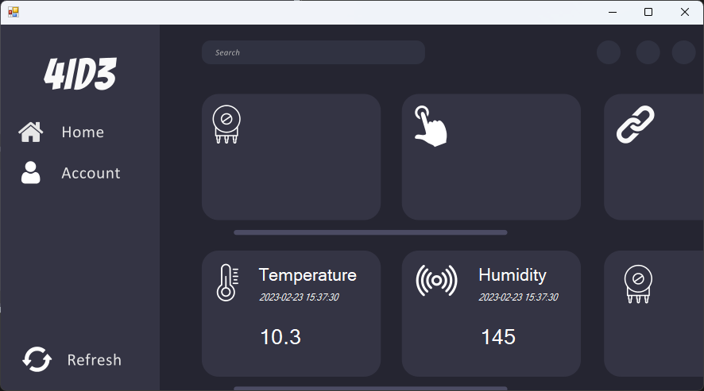

While most of these functions are just for show and will remain unimplemented, the goal is to demonstrate what’s possible with WinForms and what you could potentially build for your course project.

This project builds on the previous MySQLParser desktop application. It uses images and fonts to add styling to the application.

Start off by creating a new Windows Forms App.

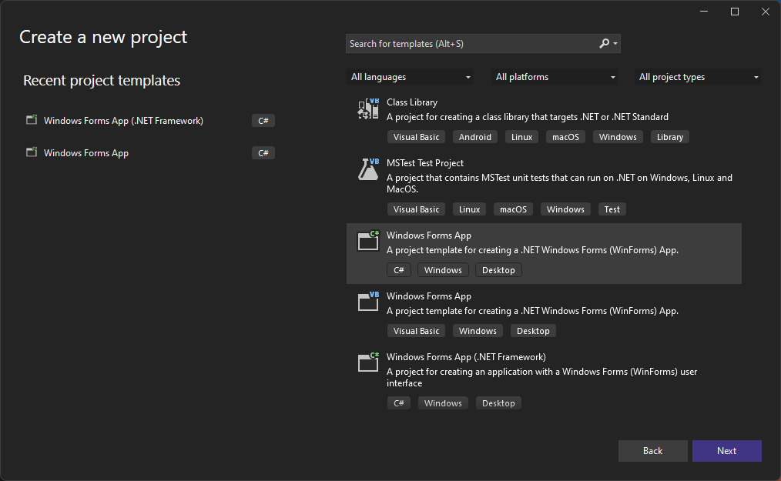

Save it in your Lab04B directory.

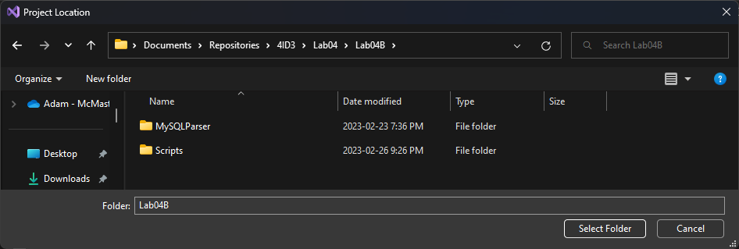

Use the latest version of the .NET framework.

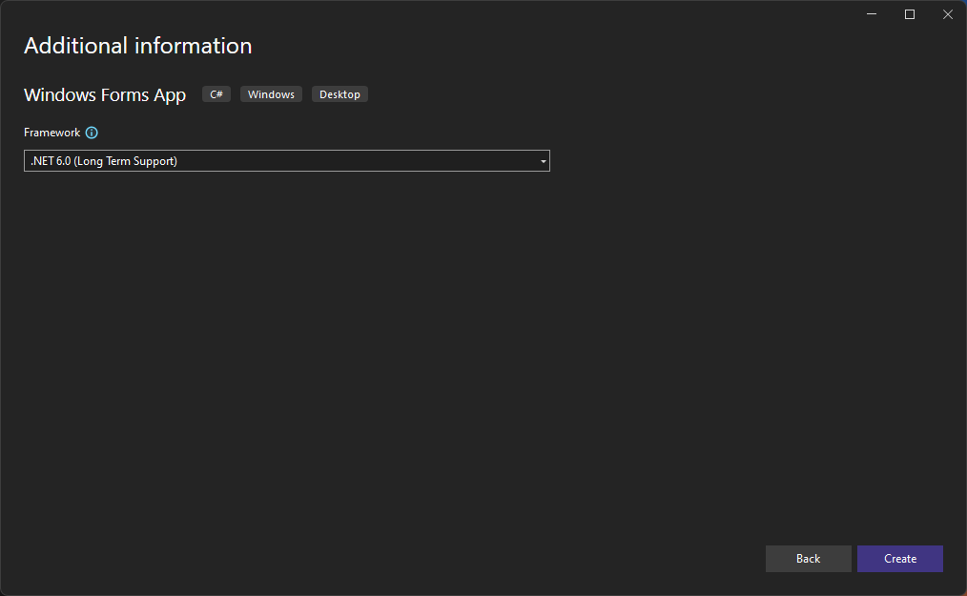

A blank project will open.

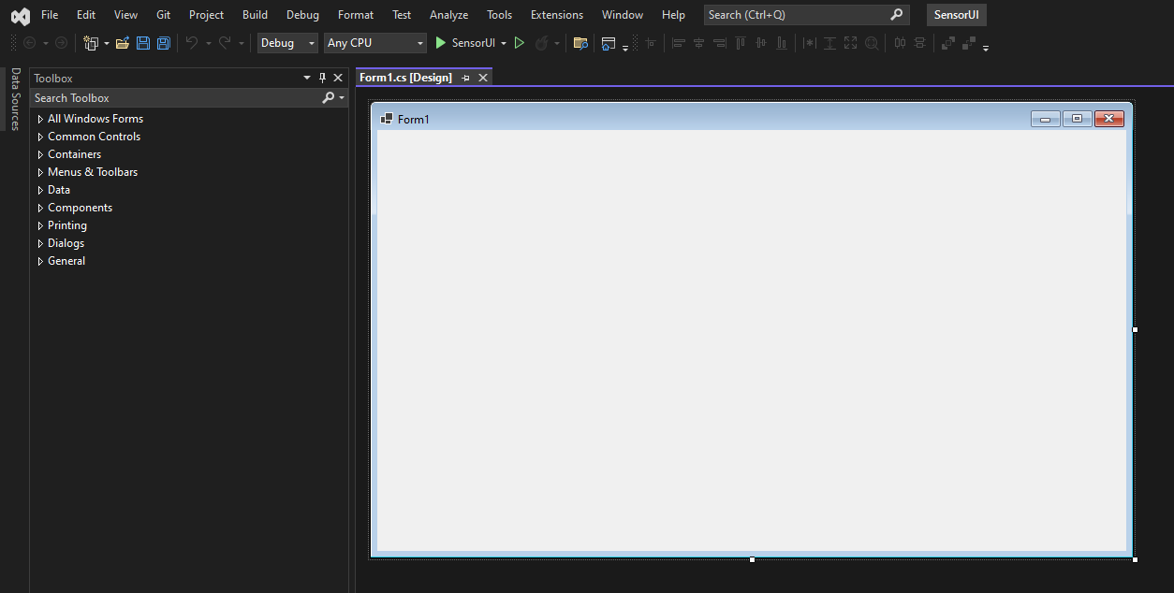

Search and drag a **PictureBox** into your Form.

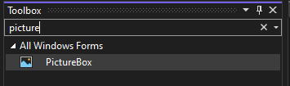

Stretch the PictureBox so it encompasses your entire form and import the provided UI image from the project repo.

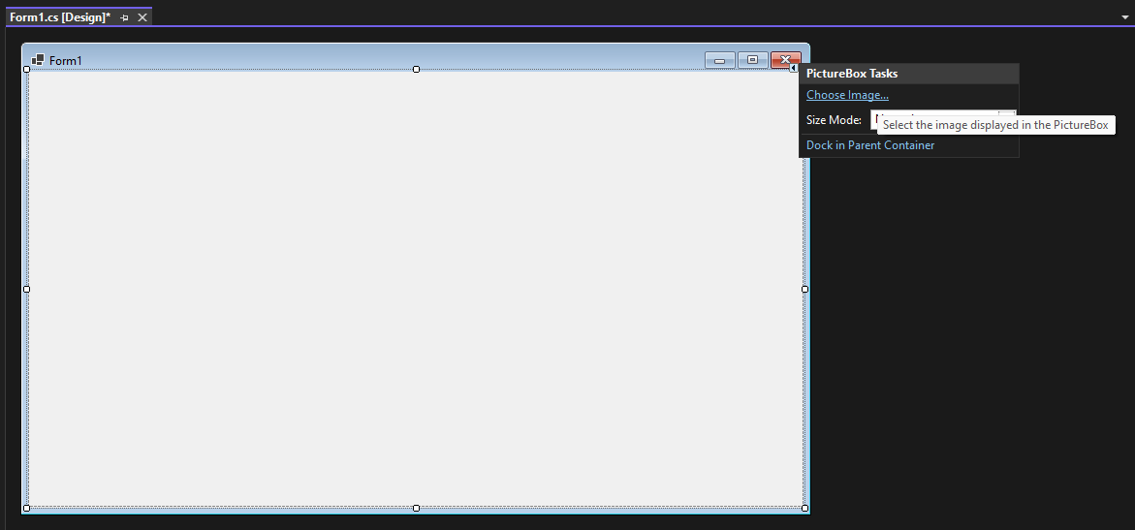

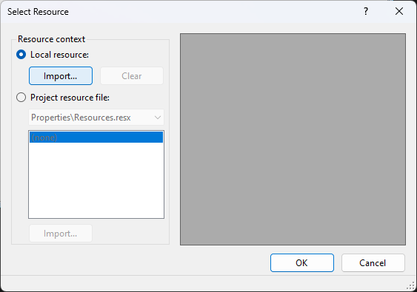

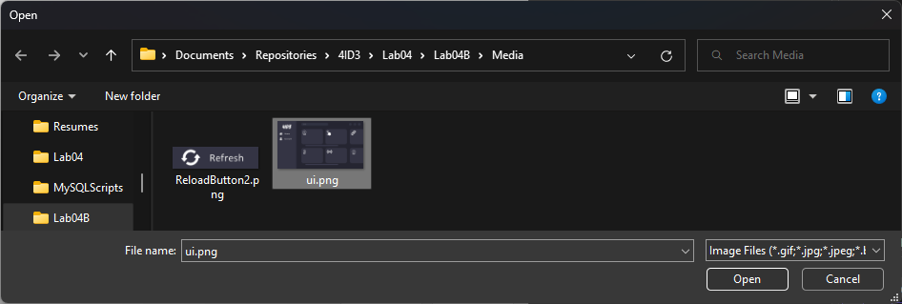

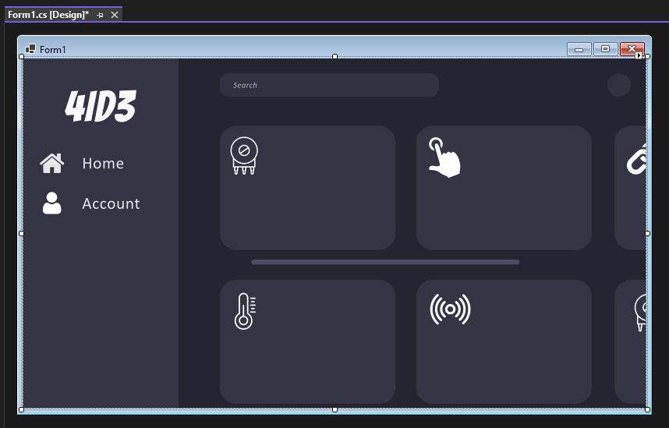

First, lets drag in the labels for our widgets.

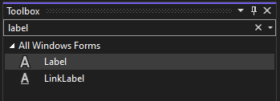

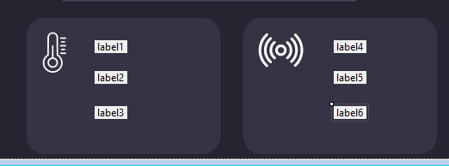

Top Label:

Appearance > BackColor = 52, 52, 68

Appearance > Font > ForeColor = White

Appearance > Font > FontSize = 16pt

Middle Label:

Appearance > BackColor = 52, 52, 68

Appearance > Font > ForeColor = White

Appearance > Font > FontSize = 9pt

Appearance > Font > Italic = True

Bottom Label:

Appearance > BackColor = 52, 52, 68

Appearance > Font > ForeColor = White

Appearance > Font > FontSize = 22pt

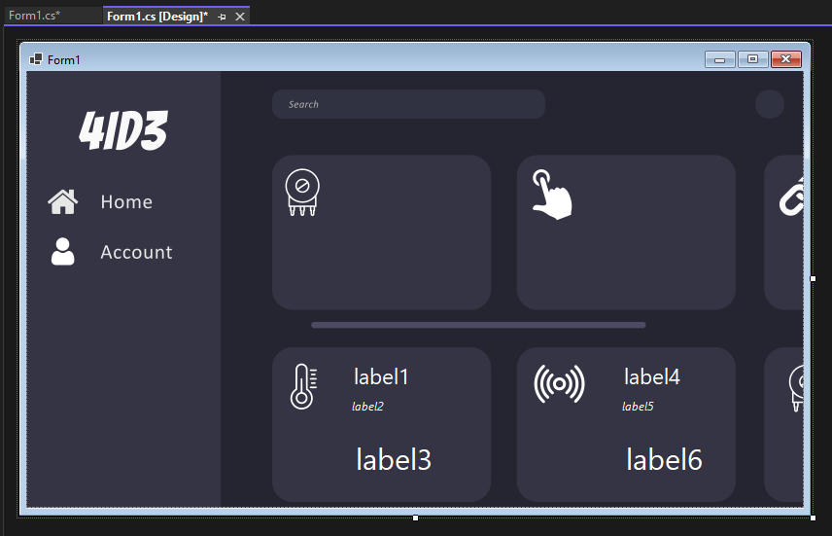

Next, we will implement a menu button called **Refresh**. On click, this menu button will parse our MySQL database using 2 different queries and update the respective interface elements.

Search for a **button** and drag it into your form.

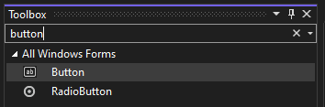

It should be positioned like this:

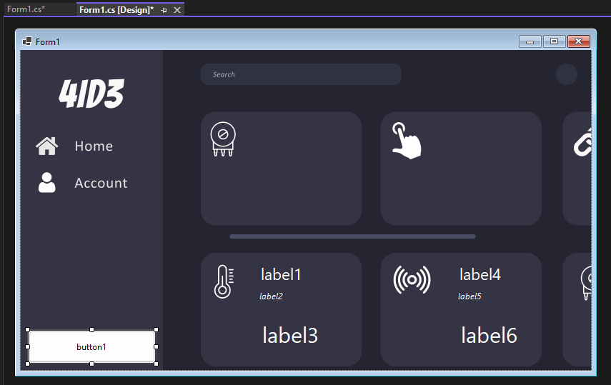

Change the following properties:

Appearance > BackColor = Transparent

Appearance > BackgroundImage = Button image from lab repo

Appearance > FlatStyle = Flat

Appearance > FlatAppearance > BorderSize = 0

Appearance > ForeColor = Transparent

Appearance > Text = <type a space and press <enter> >

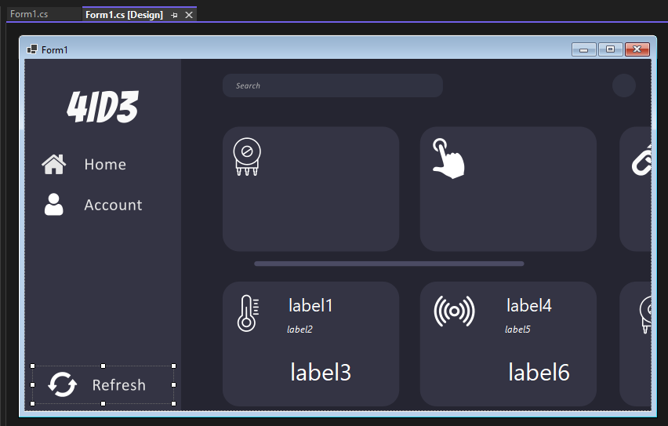

Now, we need to handle the functionality. The functionality will be very similar to the previous application, except with a pre-established query.

Double-click on the button to generate the on-click handler method and be transported to it.

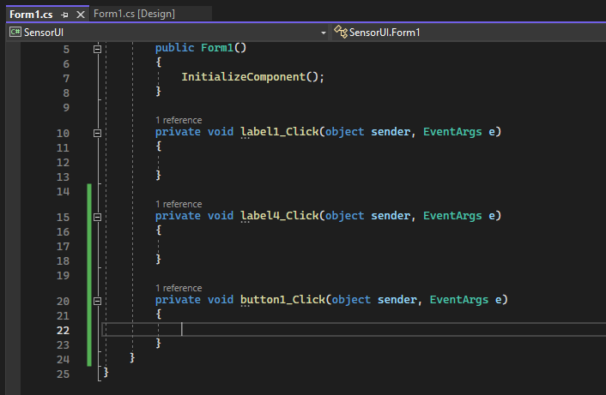

Using the NuGet package manager, install the MySql package by Oracle into your project.

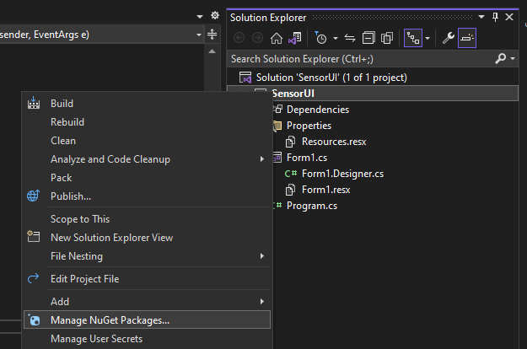

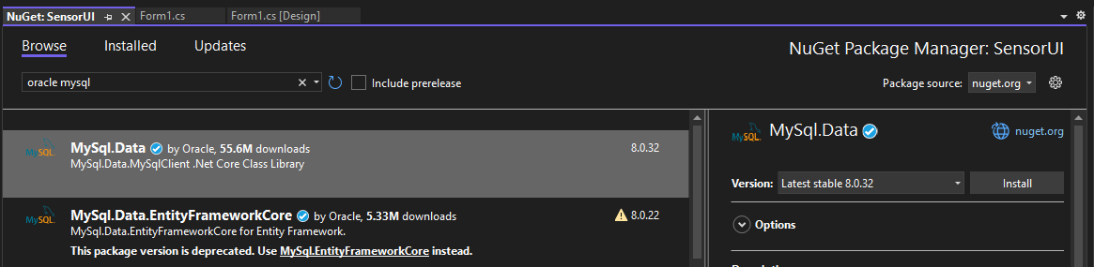

Include it into your form code.,

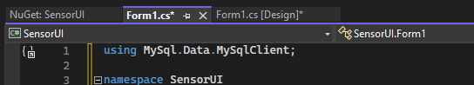

Create your database model.

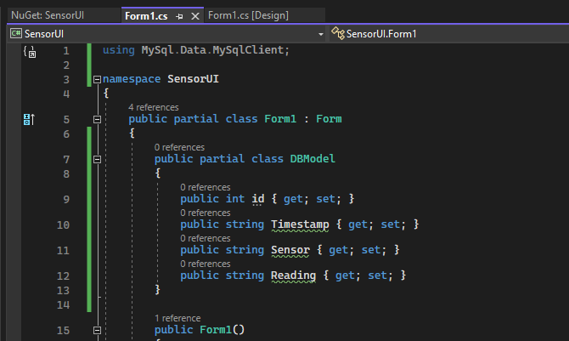

Write your onclick handler method.

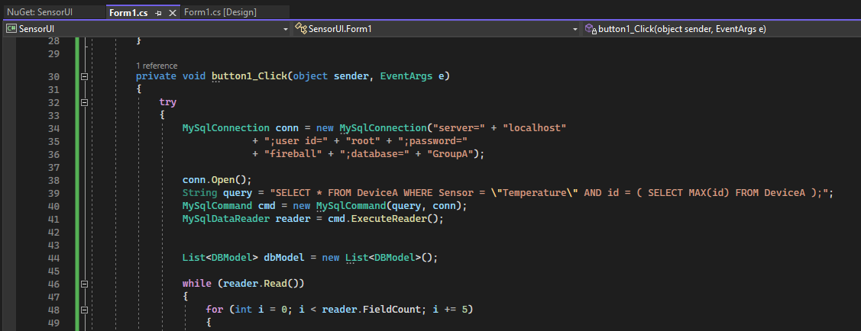

Full code:

try

{

MySqlConnection conn = new MySqlConnection("server=" + "localhost"

+ ";user id=" + "root" + ";password="

+ "fireball" + ";database=" + "GroupA");

conn.Open();

String query = "SELECT * FROM DeviceA WHERE Sensor = \"Temperature\" AND id = ( SELECT MAX(id) FROM DeviceA );";

MySqlCommand cmd = new MySqlCommand(query, conn);

MySqlDataReader reader = cmd.ExecuteReader();

List<DBModel> dbModel = new List<DBModel>();

while (reader.Read())

{

for (int i = 0; i < reader.FieldCount; i += 5)

{

Console.WriteLine(reader.GetValue(i));

dbModel.Add(new DBModel()

{

id = int.Parse(reader.GetValue(i).ToString()),

Timestamp = reader.GetValue(i + 1).ToString(),

Sensor = reader.GetValue(i + 2).ToString(),

Reading = reader.GetValue(i + 3).ToString()

});

Console.WriteLine(dbModel[i].ToString());

}

}

reader.Close();

label1.Text = dbModel[0].Sensor;

label2.Text = dbModel[0].Timestamp;

label3.Text = dbModel[0].Reading;

}

catch (Exception ex)

{

MessageBox.Show(ex.Message);

}

try

{

MySqlConnection conn = new MySqlConnection("server=" + "localhost"

+ ";user id=" + "root" + ";password="

+ "fireball" + ";database=" + "GroupA");

conn.Open();

String query = "SELECT * FROM DeviceA WHERE Sensor = \"Humidity\" AND id = ( SELECT MAX(id) - 1 FROM DeviceA );";

MySqlCommand cmd = new MySqlCommand(query, conn);

MySqlDataReader reader = cmd.ExecuteReader();

List<DBModel> dbModel = new List<DBModel>();

while (reader.Read())

{

for (int i = 0; i < reader.FieldCount; i += 5)

{

Console.WriteLine(reader.GetValue(i));

dbModel.Add(new DBModel()

{

id = int.Parse(reader.GetValue(i).ToString()),

Timestamp = reader.GetValue(i + 1).ToString(),

Sensor = reader.GetValue(i + 2).ToString(),

Reading = reader.GetValue(i + 3).ToString()

});

Console.WriteLine(dbModel[i].ToString());

}

}

reader.Close();

label4.Text = dbModel[0].Sensor;

label5.Text = dbModel[0].Timestamp;

label6.Text = dbModel[0].Reading;

}

catch (Exception ex)

{

MessageBox.Show(ex.Message);

}

Run the project and verify that it works without errors.

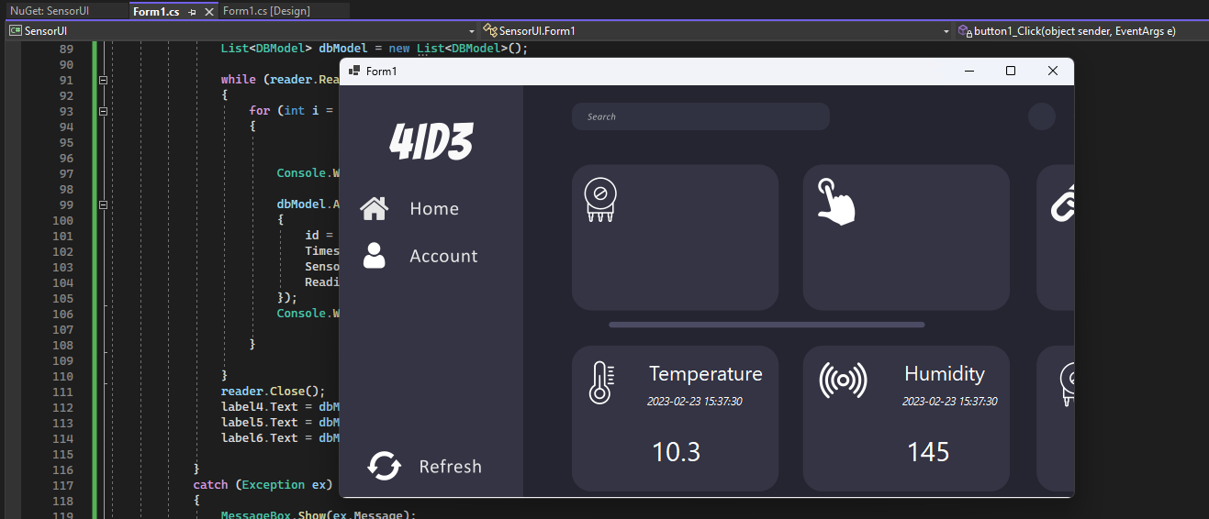

# Syncing with GitHub

Use the following commands to resync your Git repo with your GitHub remote repo.

*git add .*

*git commit -m “Lab 04 completed”*

*git push origin main*

*git pull origin main*

|  |
| --- |
| END |